**Linux Process**

**Pre checks Linux:**

uptime

uname -r

uname -n

cmviewcl

pcs status

ps -ef | grep prod

aifconfig

netstat -nr

uname -a

ls -l /dev/sd*3

pvs

vgs

lvs

lscpu

cat /etc/fstab

cat /proc/mounts

free -m

lsscsi

adapter_info

cat /etc/sysconfig/network-scripts/ifcfg-eth*

vmware-toolbox-cmd -v

/usr/sbin/vmtoolsd -v

service vmware-tools status

rpm -qa | grep open-vm

/etc/init.d/Powerpath status

cat /etc/udev/rules.d/91-asm.rules

cat /etc/udev/rules.d/91-asm.rules | wc -l

grep sat /etc/sysconfig/rhn/up2date

lsblk

blkid

ls -l /dev/sd* |grep -i oracle*

ls -l /dev/sd* |grep -i oracle |wc -l

ps -ef |grep -i infor*

df -hPT

df -hPT |wc -l

ps -ef |grep -i pmon

clustat

dmidecode |grep -i prod

vmtoolsd -v

cat /etc/redhat-release

service kdump status

service oswatcher status

service vmware-tools status

status vmware-tools

hastatus -sum

gabconfig -a

hagrp -state

vxdisk -eo alldgs list

vxdg list

hares -state

vxprint -ht

yum list updates

vmware-config-tools.pl

systemctl status vmware-tools

For RHEL 4

chkconfig --list autofs

chkconfig autofs off

**Azure pre check:**

uptime

uname -r

uname -n

cmviewcl

pcs status

ps -ef | grep prod

ifconfig

netstat -nr

uname -a

ls -l /dev/sd*3

pvs

vgs

lvs

lscpu

cat /etc/fstab

cat /proc/mounts

free -m

lsscsi

adapter_info

cat /etc/sysconfig/network-scripts/ifcfg-eth*

vmware-toolbox-cmd -v

rpm -qa | grep open-vm

/etc/init.d/Powerpath status

cat /etc/udev/rules.d/91-asm.rules

cat /etc/udev/rules.d/91-asm.rules | wc -l

grep sat /etc/sysconfig/rhn/up2date

lsblk

blkid

ls -l /dev/sd* |grep -i oracle*

ls -l /dev/sd* |grep -i oracle |wc -l

ps -ef |grep -i infor*

df -hPT

df -hPT |wc -l

ps -ef |grep -i pmon

clustat

dmidecode |grep -i prod

cat /etc/redhat-release

cat /etc/default/grub

cat /etc/audit/auditd.conf

HP Unix Pre checks:

uptime

uname -a

machinfo

lvlnboot -v

cat /etc/fstab

strings /etc/lvmtab and /etc//lvmtab_p

netstat -in

netstat -rn

ioscan -fnC lan ( ifconfig lan0, lan1, lan2, lan3 .etc)

ioscan -fnC fc ( fcmcutil /dev/fcd0, /dev/fcd1.)

ioscan -fnC processor

swapinfo -tam

setboot

ioscan -fnNC disk

ioscan -m dsf

vgdisplay -v

swlist |grep -i qpk*

ioscan

ntpq -p

swlist |grep -i bundle

model

ps -ef |grep -i pmon

bdf

bdf |wc -l

clustat

cmviewcl

**Cluster process**

unfreeze ---> clusvcadm -U pkg

disable ---> clusvcadm -d pkg -m node

enable ---> clusvcadm -e pkg -m node

freeze -->  clusvcadm -Z pkg -m node

Stop and freeze → clusvcadm -s pkg, clusvcadm -Z pkg

check df -hP |wc -l

clusvcadm -e clusterpkgname -m servername; clusvcadm -Z clusterpkgname -m servername

Or

 clusvcadm  -U clusterpkgname ;clusvcadm -d clusterpkgname ;clusvcadm -e clusterpkgname -m servername ;clusvcadm -Z  clusterpkgname -m servername

**Steps for GFS cluster:**

cluster_status_all.sh

  service rgmanager stop

  service gfs2 stop

  df -hPT

  service clvmd stop

  service cman stop

  clustat

  cluster_disable_all.sh

**Pkg in HP unix :**

Enable mode → cmmodpkg -e pkgname

Run → cmrunpkg pkgname

Check → cmviewcl

Node → cmmodpkg -n chsapp104 -e pkgppmci

For cluster cmd;

http://mailsinto.blogspot.com/p/cluster-commands.html

https://docs.google.com/document/d/1JsTo72eKmnmSqx-48eaYpV3kGw3bgbyN36PQ_40dMSI/edit

**To place package in debug mode,**

Login to the package

Exit and login to the node server

cmviewcl

cmviewcl -p pkgupdscs - to check whether package is in the correct node

cd /var/adm/cmcluster/

ls -> check whether debug_pkgupdscs  file is there

touch debug_pkgupdscs - by creating this file package will automatically go to debug mode.

cd log

tail -f pkgupdscs.log - found debug file, monitor paused has to come.

rm -rf debug_pkgupdscs  - to remove from debug mode.

**To stop Networker Linux**

cd /etc/init.

ls –lrt --> list all

ls -|net* --> check networker (or) network(don’t touch n/w)

./networker status

./networker stop

ps –ef|grep –i nsr --> it will show run or not

**DELL EMC networker(SAP)**

Path - opt/dpsapps/

 service agentsvc status

 service agentsvc stop

 service agentsvc start

**To stop Networker HP Unix**

/sbin/init.d/networker start --> to start the service

/sbin/init.d/networker status --> to see the status

/sbin/init.d/networker stop --> to stop the service

**Logs ultization:**

sar -u -f /var/log/sa/sa13 -s 18:00:00 -e 21:00:00

sar -r -f /var/log/sa/sa13 -s 18:00:00 -e 21:00:00

sar -d -f /var/log/sa/sa08 -s 19:30:00 -e 23:59:00

sar -s -f /var/log/sa/sa08 -s 19:30:00 -e 23:59:00

**Interval time**

sar -u -f /var/log/sa/sa26 -s 00:00:00 -e 23:59:00 3600

To get particular log

sed -n '/Nov 29 04:30:00 /,/Nov 29 05:30:00/p' /var/log/messages >> log28.txt

**Network Utilization:**

cd /var/log/sa

sar -n DEV -f /var/log/sa/sa17

Check issue :

cd /var/log → cat messages |more

**Upgrade Networker client:**

for i in servername**servername***; do scp -rp /tmp/pkgname $i:/tmp ; done

Goto servername-> cd /tmp

ls -lrt pkgname

scp lgtoclnt-9.1.1.4-1.x86_64.rpm servername:/tmp

**Steps to follow upgrade :**

Goto servername-> cd /tmp,

ls -lrt lgtoclnt-9.1.1.4-1.x86_64.rpm

scp lgtoclnt-9.1.1.4-1.x86_64.rpm servername:/tmp

Login server -  cd /tmp

ls -lrt lgtoclnt-9.1.1.4-1.x86_64.rpm

rpm -qa |grep -i lgto

service networker stop

rpm -Uvh lgtoclnt-9.1.1.4-1.x86_64.rpm

rpm -qa |grep -i lgto

service networker start

ps -ef |grep -i nsr

Networker does not start

https://lh4.googleusercontent.com/9Wf9rxP-vybXT_eFPWBDbMa1yYyjgTIaQKiR9STB6gykpFGPKF9NkmOYmuERsPDZeJuQav6EblmBOEYf6H0nP4xORIDLRFwaj9DMozndsJdaLkVAzD53a51oJ1jFrkKUHEZaJf_l

https://lh5.googleusercontent.com/VqNwYfCvWTgza571mkJvRY7W8QfNjNnrqp_b-40hY5tVS3Vd4342NBBmJhbZfIHjjejzah9EpOe1m9dEYU5-4OFXQS-a8L--0hYuQ_2Wq36w-irdPuBpum4zi4S2xvwFa1EASo-K

Not started means(doubt)

Goto → cd /nsr/res  → ls → cd /res → rm -rf *itm

**LVM: (Logical volume )**

PVS --> VG --> LV

**File system extension Linux:**

Steps to follow increase space

 Ø df -h / --> check the space

Ø VM ---> edit setting --> add harddisk --> size

Ø /var

Ø lsscsi --> list disk

Ø pvs --> show pv configure

Ø pvcreate dev/sdc  --> create pv

Ø pvs -- check

Ø vgextend vg00 dev/sdc  --> create vg

Ø vgs --> check

Ø lvextend -L + 5g  fspath --> extend Lv

Ø lvs path -->check

Ø resize2fs path , xfs_growfs path

Ø df -hP --> check

**File System creation:**

Before unmount the FS need to check any process running https://lh4.googleusercontent.com/EHD96nl72QW_C8F_saiGBAdKn_q678KV4BOpslZFAeN_iTXncmEtG7L5xN5u1FMGRAfSVy8wO4IK6hiOjaovWB-Ns0ggxzVx274KHlBkA5wzFREsJ9N-Dto05i1AuroxWNcQOUyg

 If not umount /oracle/UMC/18.0.0

Then remove the lv  - lvremove /dev/mapper/vg_applic-lv name

**Add disk in VM**

Pvcreate

Vgextend

lvcreate -L 20G -n lv_oracle_umc_18 /dev/vg_applic (we can give any lv name)

mkfs.ext4 /dev/vg_applic/lv_oracle_umc_18 (make fs)

Mkdir /oracle/UMC/18.0.0

Mount /dev/vg_applic/lv_oracle_umc_18 /oracle/UMC/18.0.0

Vi /etc/fstab - entry

 chown oraumc:dba /oracle/UMC/18.0.0 - change ownership

https://lh4.googleusercontent.com/IhVnfwQKdgNhbv8yaUribVMwh6bv8AHnhwAUBEtq4NQ0moYYvZl6NBrZc4khjwEaJ6BrOpsVoYUijmCSYTYibgaFdZkGSNjedD_yMsru8Cgt3vtouhR0uEAURGwDprq-SOAcHEjN

Vg had more space we need to create LV

https://lh5.googleusercontent.com/Ipb6M_tJF9su9z7q8Q0eveUcNkVzBkYySLDuMtcBnWJVzvcFWNH6Gs69cxgBtiEYxkju8E6EiYTY9yJvQvw3VJrpcoUa4OdPUg-XEaumfdgoWjcZIk1-mjBKRQGwfq4Idn9a9eIt

**HP UNIX Extension:**

Check free space in hpunix:

→ vgdisplay vg00

→ free PE *PE size/1024 -GB format

→lvextend -L <Free space>M <logical Volume name>  (lvextend -L 16884M /dev/vg00/lvol5)

→ fsadm -b Freespace M /opt

 → Cross check if the space is increased(bdf /opt)

lvextend -L 15360 /dev/vg_applic/lv_usrsapsmd

fsadm -F vxfs -b 15360m /usr/sap/SMD

**Creation: HPUX filesystem**

vgdisplay -v vg00 ----> to check free space in VG

lvcreate -L 2048M -n lv_CA /dev/vg00

mkdir -p /systools/CA

newfs -F vxfs -o largefiles -b 2048M /dev/vg00/rlv_CA

mount /dev/vg00/lv_CA /systools/CA

**HPUNIX Filesystem:**

insf -eC disk

ioscan

cd /dev/rdisk

ls -lrt

diskinfo /dev/rdisk/disk100

ioscan -m dsf

pvcreate /dev/rdisk/disk100

vgcreate -s 64 vgname /dev/disk/disk100

vgdisplay vgname

lvcreate -L 1024M vgname -n lvoracle

newfs -F vxfs -o largefiles vgname lvname

mkdir /oracle

mount vgname/lvname /oracle

lvextend -L 3040M /dev/vg00/lv_itm

fsadm -b 3040M /systools/itm

**Low disk space homes**

df –hPT /home --> file system space

Go to cd/home -- > ls -lrt

du -Sc . | sort -rn | head--> to check which person used more

du -sx * |sort -nr |head  - hp unix

find /exe_wp  -xdev -type f -ls |sort -nrk7|head -30 --> file usage

find -type f -exec du -Sh {} + | sort -rh | head -n 10

find / -xdev -type f -size +10M

Same for /tmp(remove some old files)

getent passwd xssyb  - to know user name

**NSR not running.**

ps -ef |grep -i nsr

service networker status - RHEL 6

Systemctl status networker - RHEL 7

not running means start the server

service networker start

**HP UX Message Trap**

ioscan -fnC disk

ioscan -fnC disk |grep -i NO_HW

tail -30 /var/opt/resmon/log/event.log

tail -300 /var/opt/resmon/log/event.log

dmesg

ioscan -fnH 0/0/0/7/0/0/1

diskinfo /dev/rdsk/c37t15d1

Step to given application access:

Ask server name model user ID

Login jumphost

Check with id

sh /usr/local/woolies/adduser/add_user_multiple.sh (answer all qs)passwd

Then login server check with id

Change the pswd ---> passwd ID && passwd -f ID

Note : user will be prompted to change password on first logon.

Didn’t select instance means,

Copy the file .instrc from model user id, and change the owner access.

https://lh3.googleusercontent.com/eCehDiUfxiD9s_HX0HPSOouKgfoYUkz9v-ZKkgEwSspc_-0bIB6M2SJYi0l9O8BjyK7NMAk63Rp4DYnPG7V-9mlWqsI9cAUPk2O4gSNmE7XikwRes7KHM0T8e1r1fWaLslMwYpCC

Unlock the ID:

getprpw id - To check whether locked or not. In lockout any 1 comes means locked

modprpw -k id - To unlock

/usr/lbin/getprpw id

/usr/lbin/modprpw -k id

**Oswatcher installation**:

step:1

Login cam

Go to cd /var/tmp

ls -l osw*

Take ->scp package id@servername:/var/tmp

Step 2:

Cd /var/tmp

Ls

chkconfig --list

service oswatcher status

rpm -ivh packagename

Df -h

Copy /sys_bkp

vi /etc/sysconfig/oswatcher

DATADIR=/sys_bkp/log/oswatcher

service oswatcher status; service oswatcher start; service oswatcher status;chkconfig  oswatcher on;chkconfig --list | grep -i oswat;

**Kdump config**:

check the sys_bkp fs is available or not.

#yum install kexec-tools

cp -p /etc/kdump.conf /etc/kdump.conf_bkp

cp -p /etc/sysctl.conf /etc/sysctl.conf_bkp

cp -p /etc/sysconfig/kdump /etc/sysconfig/kdump_bkp

TAKE Back up

edit -  /etc/kdump.conf

path /sys_bkp

ext4 /dev/mapper/vg00-lv_bkp

disk_timeout 30

core_collector makedumpfile -c --message-level 1 -d 31

default reboot

TAKE Back up

edit- sysctl.conf(last line):/need to enter

kernel.sysrq = 1

kernel.unknown_nmi_panic = 1

kernel.panic_on_unrecovered_nmi = 1

TAKE Back up

Edit /etc/sysconfig/kdump - remove mdump

MKDUMPRD_ARGS="--builtin=vsock"

MKDUMPRD_ARGS="--builtin=vmci"

MKDUMPRD_ARGS="--allow-missing"

#sysctl -p ----for making it permanent

#chkconfig kdump on

start the service .

it is not working, reboot the server and check.

**Steps for Kdump:**

check-->rpm -qa kexec*

yum install kexec-tools

Need to copy:

Cp -p /etc/kdump.conf /etc/kdump.conf_bkp

Vi /etc/kdump.conf

 cp -p /etc/sysctl.conf /etc/sysctl.conf_bkp

 vi /etc/sysctl.conf

 cp -p /etc/sysconfig/kdump /etc/sysconfig/kdump_bkp

 vi /etc/sysconfig/kdump

 chkconfig kdump on

 service kdump status

 service kdump start

 sysctl -p

**To provide sudo access -- Linux Server**

Kindly ask the following questions to the requester before giving sudo access,

Sudo permission questions:

* Whether you need full (root) access or is this for any specific set of commands.

* Reason for sudo access.

* How long will you need this access?

After getting those information login to the server and take backup of the sudoers file by adding the present date.

cp -pr /etc/sudoers /etc/sudoers_bkp29112018

Then goto vi /etc/sudoers and inside that add a line for which user you need to give access,

Eg. id ALL=NOPASSWD: ALL

The above example gives full sudo access for the user id . Then save and quit.

To revert the access use at command:

 at -t 11292200 --------> 11th month 29 date till 10 PM time    or at 12:00 01.03.2019

at> cp -pr /etc/sudoers_bkp29112018 /etc/sudoers  -- then enter -> Ctrl+D

at> <EOT>

job 1 at 2018-11-29 22:00

at -l -------> for checking

1       2018-11-29 22:00 a root

**To remove at job,**

atrm 4(job code)

Sudo access to particular command

javadm ALL=(ALL) NOPASSWD: /usr/bin/systemctl, /usr/bin/cp , /usr/bin/journalctl , /usr/bin/chown , /usr/bin/chmod , /usr/sbin/nginx

HP UNIX - /usr/local/etc/sudoers

Sudo access to group means add %group id

Example:

root@servername sudoers.d# cat sudoers_DEVOPS

Cmnd_Alias DEVOPS= /usr/bin/cd , /usr/bin/ls, /usr/bin/systemctl, /usr/bin/nohup, /usr/bin/tail, /usr/bin/ps, /usr/bin/top, /usr/sbin/service, /usr/bin/rpm, /usr/bin/free, /usr/bin/du, /usr/bin/cp, /usr/bin/mkdir, /usr/bin/ping, /usr/bin/nslookup, /usr/bin/telnet, /usr/bin/traceroute, /usr/bin/man, /usr/bin/netstat, /usr/bin/find, /usr/bin/echo, /usr/bin/cat, /usr/bin/chmod, /usr/bin/zip, /usr/bin/unzip

%monitoringdevops ALL=NOPASSWD: DEVOPS

Sudo access has been provided for the users till 12:00 07.06.2019 AEST. Kindly confirm us to close the request

(OR)

Visudo

while giving sudo access login as root for 2 time

login as sudo

login as xlkn1 -->sudo edit in visudo

id ALL=NOPASSWD: ALL

**Health check command:**

top -b -n 1

lscpu

free -h

cat /etc/redhat-release

uptime

vgs

lvs

pvs

sar -u >> /var/tmp/`hostname`_precheck.txt

sar -r >> /var/tmp/`hostname`_precheck.txt

sar -q >> /var/tmp/`hostname`_precheck.txt

sar -S >> /var/tmp/`hostname`_precheck.txt

sar -d

netstat -i

dmidecode |grep -i prod

clustat

ps -ef |grep -i pmon

cat /etc/fstab

cat /proc/mounts

lsscsi

**For DB servers:health check**

cat /etc/udev/rules.d/91-asm.rules

cat /etc/udev/rules.d/91-asm.rules | wc -l

grep sat /etc/sysconfig/rhn/up2date

cat /etc/udev/rules.d/91-emc.rules

cat /etc/udev/rules.d/91-emc.rules |wc -l

ls -l /dev/sd* |grep -i oracle

ls -l /dev/sd* |grep -i oracle |wc -l

**Veritas case logs:**

1. cd /opt/VRTSspt/VRTSexplorer/

2.list --> 11---> ./ VRTSexplorer (for multiple server give ./VRTSexplorer  ./VRTSexplorer sever names

3.Run this by clicking enter for all

4 save it in /applic/informatica(location)

4. once it stored in /applic/informatica

5. cd  /applic/informatica-->ll

4. you can able to find a gzip file

5. chmod 777 (file name)

6. scp (secure copy)to jump host

7.winscp-> open jump host

**Lun details:**

Linux :

Login to server

Check VM or physical

VM → login Vcenter → data store → copy

For na detail → type → right click → device

To check cluster vm → take the host name and goto → storage → host → cluster

VM size → summary →

**Physical** -

powermt display

powermt display dev=all |grep -i "Symmetrix ID"

powermt display dev=all |grep -i "Logical device"

powermt display dev=all |grep 'Device WWN' - To check naa id

UNIX: Physical → powermt display dev=all |grep -i device

(or)

powermt display dev=all | grep -Ei "Symmetrix ID|Logical device ID"

HPUX Virtual machine -

hpvminfo -V -> hpvmdevinfo |wc -l (check the count) -> hostname login

hpvmdevinfo -V -P chsapa44 | grep "Host Device WWID" | awk -F. '{print $NF}' | awk -F\' '{print $1}'

Patching:

To check satellite:

subscription-manager list  - check subscribed or not..

cat /etc/sysconfig/rhn/up2date.rpm

cat /etc/sysconfig/rhn/up2date.rpm |grep -i sat

cat /etc/rhsm/rhsm.conf |grep -i sat

Page Break

DR server activity: login via console and change the ip address

Changing the IP address:

cp /etc/hosts /home/xid

Vi /etc/hosts ---> change IP address

cp /etc/sysconfig/network /home/xid

Vi /etc/sysconfig/network ----> change only gateway IP

cp /etc/sysconfig/network-scripts /home/xid

Vi /etc/sysconfig/network-scripts/ifcfg-eth0

Vi /etc/sysconfig/network-scripts/ifcfg-eth1

Vi /etc/sysconfig/network-scripts/ifcfg-eth2

Before check ifconfig -a for ethernet confirmation

/etc/init.d/network restart----> to restart services

Mount:

Check the fstab → cat /etc/fstab and edit

Mount

Nfs not available means create the directory

https://lh5.googleusercontent.com/wHavP5VNJd3Lag1U7OG7wFpIYJWqQaFznXMhyYPVfZWZQr_T9sv6J2tTP5VycwWi-fyVL9jmQ5dimYL8a4p11Z3MIwDikLGHB-yoVfFfXocToB2InWBDKHG4kefFIgbKwAiiGCyV

Mount mlshare

https://lh3.googleusercontent.com/HPbhMAYOXE4w2jvZ_9HLGKPjK_ktP2gbLXPbccV2aKognxbxB9IROfR4Y7shClPI4QNuQSIGXuJKfPzkEoOoMfAkhL-ozTfPn0qvhsJutljhJHNnzueE9slUJDI1VK0MzymgyORM

HP unix Reset:

You can just reset it

root@servername-/root> hpvmconsole -P servername

  vMP MAIN MENU

        CO: Console

        CM: Command Menu

        CL: Console Log

        SL: Show Event Logs

        VM: Virtual Machine Menu

        HE: Main Help Menu

         X: Exit Connection

[servername] vMP> cm

       (Use Ctrl-B to return to vMP main menu.)

[servername] vMP:CM> rs

RS

Execution of this command irrecoverably halts all system processing and

I/O activity and restarts the computer system.

Type Y to confirm your intention to restart the system: (Y/[N])

Type Y will reset the server

To check CPU:

lscpu

Top → press 1

cat /proc/cpuinfo | grep -i proc

To check the Printer status

lpstat -t | grep -i printer name

Tcpdump:

Step 1: login servers

Ifconfig find the ethernet etho1...etc

Enter the command tcpdump -i eth0 -w ncdlsoaasp1001.pcap

Afer 2 min give ctrl+c ---> ls -lrt ncdlsoaasp1001.pcap

Scp the file and store it in some path (/tmp)and take the data(file) from  winscp and send to the customer.

tcpdump -s 0 -i eth1 -w /tmp/tcpout.pcap

tcpdump -i any  -w /tmp/tcpout.pcap &

Source to destination →

 tcpdump -s 0 -i eth2 host 10.168.20.25 and dst port 80 -w /sys_bkp/0001_tcpdump.pcap

Example: tcpdump -i any -W 5 -C 200 -w capturedfile & (it will capture 5 packets)

vm.swappiness:

FYI to check swappiness  → cat /proc/sys/vm/swappiness

Steps:

→ check → sysctl -a |grep -Ei "swap|dirty"

→ Take backup cp -pr /etc/sysctl.conf /etc/sysctl.conf_bkp22022020

→ edit the file /etc/sysctl.conf

(vm.dirty_background_ratio = 3

vm.dirty_background_bytes = 0

vm.dirty_ratio = 10

vm.dirty_bytes = 0

vm.dirty_writeback_centisecs = 100

vm.dirty_expire_centisecs = 500

vm.swappiness = 1 )

---> execute the command --> sysctl -p  and the check  sysctl -a |grep -Ei "swap|dirty"

→ then take backup and reboot the server.

To check utilization graph:

RDP → VM → Monitor → performance → advance

MP logs:

Login console and proceed to below steps

MP> SL  then Select "system events" (E or SEL) then a dump (d)

MP> SL  then select "Forward Progress" (F or FPL) then a dump (d)

MP:CM> PS  then select "Cabinet" (repeat for all cabinets 0, 1 & 8 if exists)

MP:CM> PS  then select "Cell" (repeat for all cells)

MP:CM> PS  then select "I/O chassis" (repeat for all I/O chassis)

MP:CM> DF  then select "dump" (d) then select "all" (a)

MP:CM> SYSREV

(Settings → logging → All session output → browse → always append )

To collect getsysinfo :

servername→ /tmp → ls getsysinfo → scp getsysinfo.all.tar.gz sysunix@servername:/tmp

Steps:

Login server → cd /tmp → list getsysinfo

→ tar -xvf getsysinfo.all.tar.gz

→change the permission chmod 777 getsysinfo.all.tar.gz

→ not run means gunzip getsysinfo.all.tar.gz

→ tar -xvf getsysinfo.all.tar

→ chmod 777 getsysinfo.sh

→ run ./getsysinfo.sh

https://lh4.googleusercontent.com/6Son_fvunUfarBQQN2FPdIX1vIOXXkiFsWgY863TlkU2HdDHmHJaGwxad1MNKavuoNGhBwVAVD5VaZ9mTaGxvwMNVXbIbtuvNMg2TsZlfjyfllVCVM_AO6KyLunCk4SYlKvM-knz

**** steps for hpux sysinfo log  ****

unixrep@servername ~$ scp -rp /tmp/getsysinfo.sh thsiwr1:/tmp

log in to the server

cd /tmp

ll

./getsysinfo.sh

scp -rp /tmp/sysinfo_servername_202103271747.tgz xvjm2@servername:/home/xvjm2

winscp to our pc and then upload the file

User Creation: (REQ0631844)

   id saprtr (check service account)

   cat /etc/group |grep -i 527 (sample id group)

   cat /etc/group |grep -i 1000

   useradd saprtr

   usermod -g 527 saprtr

   usermod -G 1000,527 saprtr

   id saprtr

   passwd saprtr

   chage -d 0 saprtr

https://lh3.googleusercontent.com/IavUd4_YzIK0KfloehZV1lXiG5gZncZ6t5nsnGuVRxjCl7Stw2Ful8PMeRSAKxZbs_JvE2tVxA5mKRRgjyFOptFLxDX2LobPlDGFFpP8oO4Yy1r18g0tMRGb8RmNqIOvPutdQuK_

T - Shirt Size :

Check cpu - lscpu

Socket *

Check memory - free -m

Check battery status →  hpacucli ctrl all show status

Server running in different time:

https://lh5.googleusercontent.com/InJBjpb3ZdpKYFNdkH0axexTC5q-zyw4gNTciG416pPEAxO1s7TDwP9099s0-ZMjEYA_srWTdQ0MbX48RPEB4cj5--kWYLXFzn2KgvQREjmdN9jPbYpSstcTH76bKesKjnHSXqJV

Check the ntpd status → Service ntpd status

Cd →  /etc → tail -100 ntp.conf

Cat /var/log/messages

To check NTP servers and service details

cat /etc/ntp.conf | grep -v "^#"; echo "HIIIIIIIIIIIIIIIIIIIIIIIIIIII"; ps -ef|grep -i ntp;

https://lh4.googleusercontent.com/nfoeZOWRDhcKzsbWQ-C3PBi9yqpNtDf8FCjIaYuHUPis4Jd1kqbtEKxH0apzyKaP0z7cMIZYi0fGDbOMpxhMr4apljVeRx6gFXFsRuAkEl9rJfwWxBqOEjlLXLmKvNoLTyBV9x44

HP O V MESSAGE TRAP :

ioscan -funC disk |grep -i NO_HW

powermt display

powermt check

To check port available:

netstat -an  |grep -i 1531

lsof -i -P -n |grep LISTEN

netstat -tnlp |grep 8031  - to check port status (listen)

Free memory utilisation :

free | grep Mem | awk '{print $3/$2 * 100.0}'

UIM install

check /systools/CA file available on the server if not need to create the FS

1.copy the file --> from in tmp location

 scp uimagent-1.0-0.x86_64.rpm id@servername:/tmp

2.login the server goto /tmp

3.install the package -- rpm -ivh  uimagent-1.0-0.x86_64.rpm

3.start the agent - service nimbus start

check whether running or not -service nimbus status or ps -ef |grep -i nimbus

UIM manual installation:

1. cp the files nms-robot-vars.cfg and nimsoft-robot.x86_64.rpm (servername) to the servers

2.kept the files in /opt

3.install ---> rpm -ivh nimsoft-robot.x86_64.rpm

4.cd /opt/nimsoft/install  -> ./RobotConfigurer.sh

5.start the nimbus --> service nimbus start

https://lh5.googleusercontent.com/aEHSqb1WWwIr3umv03DavwFVzlBHe-MggOvU911r-pt16AH9jN01DDv6nuhKqnXr0FDpLOlnvEA2wLMxbOPagwZ-YNRpZG1epCAyyFGbC4foXs3NSiHBO-g4CJDYKWihJEFmqAUa

https://lh5.googleusercontent.com/KrxCs2fBojW3GzZhXIx1pZLhQRjDUysP3FNH2q28TsTPvgTmoHlYtLykX_W4wac5r2xoatGXJBdT2tFIjnzAq00Z2IjoSpiqdyMoKyInuMJtcfEZsNWbTXOCXuOH0k81xAmwBkQw

https://lh6.googleusercontent.com/2O1nFv_zy39Db0Kq8n69amiYkuLW4lQPI0TypvqDFezhbFPQd5y-vEoj2MsIv5BLVmv9RWVRq66AbP6wiaM_nLssB5Y7HNSMXGJyLYJa_PrFDxHP380go27HYHYrEb4MZGSo9pZQ

****************************************

sudo /sbin/init.d/service CA-SystemEDGE status

sudo /sbin/service CA-SystemEDGE status

sudo /sbin/init.d/CA-SystemEDGE status

Network client upgrade 19.2:

scp nw192_linux_x86_64.tar.gz

Yum remove lgtonmda-1.5.0.1-1.x86_64

Yum remove lgtoclnt-9.1.1.9-1.x86_64

tar -xvf nw192_linux_x86_64.tar.gz

cd linux_x86_64

rpm -ivh lgtoclnt-19.2.0.1-1.x86_64.rpm

Service networker start

tar -xvf nmda192_linux_x86_64.tar.gz

rpm -ivh lgtonmda-19.2.0.1-1.x86_64.rpm

Sosreport and winscp:

Support case → open case →

sosreport --all-logs

unixrep@servername tmp$ scp -pr servername:/tmp/sosreport-20200802025333.tar.xz /tmp/

Tumbleweed - scp -P2222 servername:/tmp/sosreport-20210308195538.tar.xz /tmp/

Sosreport for suse -- supportconfig –l

NFS FS issue:

root@servername ~# /etc/init.d/nfs status

rpc.svcgssd is stopped

rpc.mountd is stopped

nfsd is stopped

rpc.rquotad is stopped

root@servername ~#

VM space issue after reboot troubleshoot:

hpvmstart -P chsapa21

hpvmstatus -s

https://lh6.googleusercontent.com/5EW-Zd6Af-HILBCI_ZcQoVh0uHMHG7jAItMtB2_0VypuzIP2D77TndBj28pAgNLv2MFd3Mhtr5KwQSYuXGiKdDTrIskt5ew7J8NuJFpGpVZ1zhLY9Qjjmte9iIhpZ4_guUcUBPM3

Once VM start login server if filesystem count is less means follow below steps:

https://lh6.googleusercontent.com/8LC_nawYXJig3emhZQqnpqFpVmMKzA2IVcPvUyUBN2Oa5bOp_5wCNd_PDBT3dqLDfksFIBHY-MLIux0AO8QU1cSjO3j0XbgBzmuI4crJQu2L1PUY63eEnlbg9tNjJbzzRTQ2U5X7

**************************************************************************

HPUX to display cpu & memory --  machinfo

To display disk #sam  option>f --option>d

CRON JOB access for user:

go to - /etc/cron.allow

add the user in the file

save it thats all

user is case sensitive

if created by small letters

mention how the user was created.

Permission for particular user eg:

setfacl -Rm u:svc_optumera_nonprod:rwx /opt/apps/Macrospace

-R for recursive

-u for user

https://lh4.googleusercontent.com/wbueuEUhGcnC9w9PFQjNkjRhUnh6DfOus_myCJU4zSZ5baRZck_duX24oxKvn5X2dAnRBitcaozSQ0HtB-0EzD_PnYeENEf4DNmyM5i2Unw1IvXGEzGC1EZusAoxRzgEHhyl4_Cx

After execution https://lh4.googleusercontent.com/KQF1alM-A6Ey9u2LCE2E2Q_FJ4qPcfEIt3HgtG4UbF63bgN9vRJ_ceAyIgTRrQbLC31N1aRuufZhvPNJOkTfID7uhKdQgSjXMQimodjMmJ10UbaNY0mQT05IWpMzQYp7Is96QJWD

While patching if server not showing yum list updates

If it show error like this

Shape https://lh5.googleusercontent.com/PZXOFpa-LBqXYjeaTZiEzN3IEtHSzVUFoZWTTdHyajviXlHa76VxN0fBKcF1OTo8hQBz-twyktI_9tgOsp3zDqzcI-F-MUlZeQ06AjIZys8tfnHpB89plXdNb9VmWG5q1tCmZ9nU

Shape https://lh6.googleusercontent.com/LPuh3cTIzebyeegaxUqJ6wHemHuhyJDI0HSK7grBVmTf1kUF-PUfDGUDji-0Qn7vXJyEznPh0TQZ1JVUqLYq33VOgX7A1uc6XeRFJLCB4CrAr5stS6jfGpSIRZfFS9WWJ7doGbEr

https://lh4.googleusercontent.com/yckD-NDuz8F2BWy1K9UlQMn3JYxaeL5hqNBcqAk9fwbRjpkqTqrXTM17xGt6eAt0tqTuJDZo4fakOQq34pZivyj-nJ_5r6fS2vwt_E8aBBvgs4nY9fDvyTVuHBAGn9UkUWSLaoN_

Follow above steps

Port:

netstat -na |grep -i 4606 -->to check the availability ( port restart we can’t do )

Check this below command

https://lh5.googleusercontent.com/k1eRCXo2EbS0uDp9txJheqHTcizGqN8AvlGlunzBN9t1lPByeVvPUTyF5o4z5Ta0m0r58ftCrhQRJPX2p-gWNPu995Fgvu07QVwD9CDLLj6RCabUla6eUAzHu_cDnMbzPKdLj2Ki

In this case nsr is using the port 8000 so we need to stop networker. Then the port will be opened and free for the application team..

https://lh6.googleusercontent.com/IR30aplsVugJSYOqiWaAwczVqsc0UIh_ju_eqFLrveHkP5RwlC16SGqEGkrVMo-LpwkaTlQrej207jfGvFn3vJ8I1VCZMgNYa2kqQ8jDdayHT6tnCpqLNih0TfwjcQYEfEa6Pxf4

Softlink addition

https://lh4.googleusercontent.com/JwSiup7BmAlcdDyQTaTtz_bcN5ZEZgvH0u0ET0H1jjbZXHkjNZ9fUR90DYjOaO8ihKcFHyZpUTcXACDKm3hzKwvaakrhY9dYz5DItqDT1pcb162Dn9sQAYoV9DKNlANDh3DT_y2q

Patching /var space issue.

Take backup on the file /etc/yum.conf

Edit the file   /etc/yum.conf

Change cashedir = /var/  to sys_bkp

After patching done change

https://lh5.googleusercontent.com/CaADDArWiUvAQNlnspyoZrTuzL0t0CR7q8ofk9TzzHGtabRzwoYN4gNGpf10mG7Ge_6zRCaV7eab42hd3NAImHZbyZrPl8y78Dgq-e1ZSp4axdcj49_UyW_WVQlQtCDw5aiPAvTB

Grub conf in azure:

https://docs.google.com/document/d/1qAvGtXUzyi2gCj1dq5Ps1yqpOfDc8e2lJPw7U3Q0HPY/edit?ts=5f5a0a4c

If alert triggered for below process not running: false alert

there wont be rsyslogd and crond process running

names will  cron and syslogd

Azure servers:

To enable the kernel option.

cp /etc/default/grub /etc/default/grub_bkp

vi /etc/default/grub

GRUB_TIMEOUT=5

GRUB_DISTRIBUTOR="$(sed 's, release .*$,,g' /etc/system-release)"

GRUB_DEFAULT=saved

GRUB_DISABLE_SUBMENU=true

GRUB_TERMINAL="serial console"

GRUB_SERIAL_COMMAND="serial"

GRUB_CMDLINE_LINUX="crashkernel=auto console=tty1 console=ttyS0,38400n8"

GRUB_DISABLE_RECOVERY="true"

Please give the command.

grub2-mkconfig  -o /boot/grub2/grub.cfg

*******************************************************

If we need to change the user id of the user: hpux

cat /etc/passwd|awk -F ':' '{print $3}'|sort -n

print uid field and sorted

in ascending order

To find the words or something in vi editor - /text (eg: /xssyb)

*************************************************************************************

How to add static route entry:

ip route add 10.166.56.198/32 via 10.168.9.129 dev eth2 (need to enter this command in root)

To make it static we need to edit the configuration file:

cat /etc/sysconfig/network-scripts/route-eth2  (based on the ethernet IP -->ifconfig -a)

https://lh4.googleusercontent.com/GCRJOnqbCxT-Y8zGIoAoVfaAXBIMwB3las9FbEsYkCyTMSjxUK-FGWcM1ncFFA2vOCCE2e9OjmYdxZEazRdSY5QjWS3EqJ6LNU8eXfmvCvJsKtq3_yjtYbIDL7xUzcPPwDeF-Yfk

https://lh5.googleusercontent.com/3fIlovQLQGbQoIcAgVMJSLiqeUpplLzc7RcHcgNm3c9I9VOOYVNzqj_eXpqzrovZVn_RI0XaTL2f7kF0FIOXU7INMkbVi5_bGWGKPjp1EIqQC72Cj8Ec8DQlw6G89CgF2xvxjTWl

Sample:

Shape https://lh3.googleusercontent.com/F6eun2iuH0k7542NcUda0gQmwxiYVBn4lZZB5BO_CNi2Dn0FnFjld8hR_DQOhP9oYcaf5VybHOrpLo2rwaYVJFdTngCWQqW3jamwobi96NsNoUvoHVbiqp5gjOzNX-CKwweI9Rvz

To delete the route entry: enter below command

ip route del 10.166.56.198/32 via 10.168.9.129 dev eth2

To Check tcp running or not - cd /var/adm/crash/tcpdump

NFS Scenario based:

Both 0001 and 0002 having NFS when 0001 restarted the nfs will not running so we need to start the nfs in 0001 and in 0002 we need to mount the fs.

https://lh6.googleusercontent.com/sgQRcpPCwoPwUrao9jByTYO3edZEu9rt4kKuDSAhCehwAsyvMJyVWdnbqS2cxkTaBxQ1ddd_B-Hj3d3LzdcFq6e14lyu9xx6Z7TDH8DqLjKPQIGa9B3tm604o9OIqknX-J_8C4t2

https://lh4.googleusercontent.com/foA6cTUVrmrKpSP62bA3H3X2QYw5Z_KWrQOGeoF630fPP1GWbjXCNNwOri2r1yguT4VSgUE2uj5E5wqWZ6CP4yNTVcWM6IQYDBKKJHzPOJ5sHwedY9qlBSZQTLhfyeAf2Tzz6TJ0

********************************************************************

Data storage details: for physical server

powermt display

powermt display dev=all

powermt display dev=all |grep -i "Symmetrix ID"

powermt display dev=all |grep -i "Logical device"

powermt display dev=all |grep 'Device WWN'

***********************

Steps to install libstdc++ -

Copy the file servername-->/syslinux/sap -- /compat-sap-c++-4.8.2-16.el6.x86_64.rpm

rpm -qa |grep -i compat-sap-c++-4.8.2-16.el6.x86_64

mkdir /usr/sap/lib

rpm -ivh /tmp/compat-sap-c++-4.8.2-16.el6.x86_64.rpm

ln -s /opt/rh/SAP/lib64/compat-sap-c++.so /usr/sap/lib/libstdc++.so.6

nm -D /usr/sap/lib/libstdc++.so.6 | grep -i GLIBC

JAVA open JDK 1.8.0 install:

1.Check the available versions from the satellite repository ---> yum list java-1.8.0*

2. Install the package → yum install java-1.8.0-openjdk.x86_64

3. Check the version → java -version

4. Change default java version, in case of multiple versions.  --> update-alternatives --config java

 Application team asking to pointing 1.6.0 means we need to select the number 1

https://lh3.googleusercontent.com/WDJHYjMvMdaE1ORTrg18-lnCExIt5jxzD7Bec83FhEn62uI-2fNqQojKGhDWnZ1F1j30nquTSs3YxII9C0_Amu83LeBUGDpy8x7MljFJfk3W5XrNPLUtjREZNa8-Sto_aqfo3Zrf

https://lh3.googleusercontent.com/TMa4-oXZgGKrh2ylQK7Q1s0gr50sk9Qpl6cVRQaEJZxhjcJYvlvin0_Xg3u_abxbrKP63pm4JhaqdJGuj5dCPlFj98S6DOe769MidBorRe0Up62ApMQCcwz9vHx3BnU8wOA18cbF

https://lh3.googleusercontent.com/IqOIVK7uuB5pv4Z-AyB3Cu6EMj84oW9E3tT10NnV1svpkY5bzq1NKD2Ma_-X5NB21B26aOsySrjY_xCnoMexH2xQsI9glglGFa1bSX7-Xxm7wHLvYUsD1BNRHCJGg1CbZJ7HWc12

https://lh4.googleusercontent.com/z_GpGJOmMb2-fWjwxncyRbxAyyILRV4Gmf0ukhqM082aQ3evzCT7iEfjak4JkQxGQEWZr3tGANt4W2_GnhCFgcF2Meh74eUENhaBC12NcZWCzbpXuNKo6cosGQCBcG7KUK7S3oC4

**VM resize in azure:**

Poweroff  the server->go to azure portal->check it is stopped->perform the change -->go to size->select the size(example: D8sv_3: 8 cpu and 32 memory)--> click Resize

Ignite backup:

#inserted

mt -f /dev/rmt/64mn rewind

/opt/ignite/bin/make_tape_recovery -x inc_entire=vg00 -P s -v -a  /dev/rmt/64mn

Export file system:

https://www.learnitguide.net/2015/10/step-by-step-nfs-server-and-nfs-client.html

Server not logged in putty and logged in console and performed this

https://lh5.googleusercontent.com/HfCz5qMOdqXqS7NVxXZUNVS_Nb5sBFKt8rJI5hNFyyWfKGMm3q_XZFMuooZJP6IyJDgJcAksXhBoXzdxvF78gAE38zFAuCYOrRynWtqzzRTdfsc8D9YCyYLf3cOVZA559S-E8-u2

Check glance once for cpu and memory

https://lh5.googleusercontent.com/IlYjXxnZ1De-Ncm0g1Ysae56ksYYU1D1vDapKebyOX3Le4Mj60in76NKxYjCzlkfABupo0Hoo-OqhA9K4IZRZt9lDMXnHHVhep4w-4QVBjUIG2ygqpCuFiqMj1fZIcWm5K0wvKbd

HP case Tape drive

ioscan -fnCtape - to scan tape drive

ioscan -fnC disk - to check disk error

cat /var/adm/syslog/syslog.log - hardware logs and OS logs

Adding DIsk in vcenter for filesystem

Use browse option: if we need to add new disk in existing device

Multi writer option only for cluster (sharing)

Scsi :0 -->os

Scsi;1 -->data disk (in this only we need to add if it not there pls check scenario)

https://lh6.googleusercontent.com/u6AttIdieGMPZMoAYiHkT9IsYLoYhdlZURSdGYIg4VIKeaLt06ivy4d_2vB8tKaey5VMh3xqvOpq4ECIH6pFHwNrolkefGSql9btbVzaAhK4Ogllay0SFQ4rWRVCp-hT9lF4hP_6

To check Printer logs:

cd /var/log

cd cups/

ls -lrt

-->check error log

cat error_log |grep -i printername

ex:P780

zcat error_log* |grep -i printername

zgrep "P780" error_log*

zgrep -il "P780" error_log*

save in local /var/tmp

vi error_log -->/P780

lpstat -t |grep -i P780  --> it should be enable

To check timezone hpunix:

# cat /etc/default/tz

# cat /etc/TIMEZONE

File system not listed

Having issue with nfs (hpux)

Restart the nfs services

/sbin/init.d/nfs.server stop

/sbin/init.d/nfs.server start

File system not listed linux

Having issue with nfs (eg: clsapp301 - /usr/sap/install)

Unmount /usr/sap/install not umount means umount -l /usr/sap/install

Take backup /etc/fstab

nslookup

Change the nfs name

Mount -a or mount /usr/sap/install

To list without nfs file system - df -hl

To check which user logged in fs --- fuser -c fsname

Steps:

umount -l /usr/sap/install

df -hPT

cp /etc/fstab /etc/fstab_bkp2105

cat /etc/fstab

nslookup sapdsmcis (copy the server name and paste it in fstab)

vi /etc/fstab

mount -a

df -hPT

df /usr/sap/install

df -hl

To find the file - find / - name logmon.cfg

nfs

df -hPT

cat /etc/exports

showmount -e

cat /etc/rhsm/rhsm.conf |grep -i baseurl

hostname

baseurl

/pulp/repos

iptable -S

systemctl status firewalld

df -hPT

NFS sevrice

mount -a

0001-->login-->df -hPT --->

unmount

Downgrade if kernel panic:

https://lh3.googleusercontent.com/b5V6060R1dUk6DIoTOlvpxmef4yA3mGWPnfAqQGFvCN9la_ulvS6M0yCv5iFh1SJROlvraMLDEwJtllumQv7aO1Zz2hcXtmAhGdqQG9wNsISJaswkSV8iWX0qgU7CR-pcUFM1K65

https://lh6.googleusercontent.com/WRbizVq3VCuDpCggbppbQw2TxRbk7fcP_ftJ71_YP4kfjMdNwDsr8MJUKUCgeH-O9zpC3hcnOHZYm5uXCWyTW_EgJfsDm-VMSzwgTKQtYGhF0UcpiDV-C6OnwsuBAXvKWXh2P4Bg

Note: after this new kernel update restart the server again

For SAN Lun details:    ls -la /dev/disk/by-id/

FTP:

yum install ftp vsftpd

cat /etc/vsftpd/vsftpd.conf | grep -i local_enable

systemctl enable vsftpd.service

systemctl start vsftpd.service

ftp

For TCP packets trace:

=======================

root@servername-/var/adm/crash/tcpdump> pwd

/var/adm/crash/tcpdump

root@servername-/var/adm/crash/tcpdump>

#./start_trace

#./stop_trace

Converting binary to txt

netfmt -f /var/adm/crash/tcpdump/WMS.TRC000 > tcpdump.txt

or

nettl -tn pduin pduout -e igelan -c 2 -n 5 -tm 99999  -f /some_fast_filesystem/raw0

here -c is the interface instance no.. note: u cant porvide the 900 901 names

Once capture completed Stop nettl packet trace as soon as possible:

# nettl -tf -e all

To read the logs in text

netfmt -f /some_fast_filesystem/raw0.TRC000

nettll tool

UIM agent hpux

1. Copy the uimagent tar file from chunxs3:/sysunix/uimagent.tar

 2. Untar the file and keep that in same place

root@servername-/systools/CA> ls -l | grep -i uimagent

drwxr-xr-x 5 kekg1 sysunix 1024 Dec 29 2016 uimagent

-rw-r--r-- 1 sysunix sysunix 69949440 Dec 29 2016 uimagent.tar

 root@servername-/systools/CA> pwd

/systools/CA root

 3.Install using below command swinstall -s /systools/CA/uimagent

 4. Verify using below commands

root@servername-/systools/CA> swlist | grep -i uim

uimagent_ia 1.0 uimagent Agent for HP-UX IA

root@servername-/systools/CA> ps -ef | grep -i uim

root 10755 2939 0 21:50:02 pts/35 0:00 grep -i uim

root 9905 1 0 21:48:32 ? 0:00 ./nimbus /systools/CA/uim

5. uimagent_ia for 11.23

6. uimagent_pa for 11.11

 /sbin/init.d/nimbus_boot start /sbin/init.d/nimbus_boot stop /systools/CA/uim/bin/niminit stop /systools/CA/uim/bin/niminit start

UIM Agent Installation

Tcp ping in azure

https://lh5.googleusercontent.com/l9ufraRZOKQJyEPLpJyKliTQpZNK-H_5ESQC1Eugik7ch9_8I4TzrI0TedfC9PSrYtcnAsFAVa9PEzjZXCW5Heq9_hpW_Homz7ij9spI47ojse-U8uRNW_UbMPaZo2XbQsebk_Iz

https://lh3.googleusercontent.com/WJBWVB0U7ZVWsiRRBSuLHfjMgebAr8oZchgSNzivI6TcFnFYSJJCExnsqzb7XIoUqAhgzBmOO-k-ECQBwsL6T_dUNsn_Unk_POBuwWjgE344AsZ8icQHYSE2a87nTgfT9iAPyt4p

Rollback from 7.9 to 7.6

https://lh6.googleusercontent.com/NHKBT0WzJGVaX4Cj1Nbl5tP23T-bp2sLF10FoT9wS7CnQLjHRR2f1OvBzGtsn_RHEAjvBlQlEhAMbSYF_9ohzz-Z7eo46jLKDZ5yPWpw2G_1kduIjmn0uo1qWaKUbDmnI6sycqch

https://lh3.googleusercontent.com/LrEgmkewXuNLZaaPYU_l5SjBNyH_0GsmCQhLD_V1M1TPo2mUJ2QR5lSZU-xcJTXiBMjtwj6OfxQkQgHd3pCtK0eqn2r2RfFsAcMeTVdjkWAdUYB8wJZ61d_9Q07iwPD-mLbdtiCJ

In this when running yum history undo 21 -->it shows some error → yum-complete-transaction --cleanup-only -->copy this and give below

https://lh4.googleusercontent.com/C8-9gGZKKa2ed1WcQG5ki_vOK7BhMS9wVar1VMjMofNDKRJpG1XicTfeESjicMVr-ceDpSB-hXk4aLPfe-Csdd13OThTArI6PqN8TfaLGHPUE7uBKVR5PJO_OgAmiJC4sKdmey1k

After sever up give yum clean all and then give yum check → to check any error coming or not

Crowd strike:

cat /etc/redhat-release

rpm -qa | grep -i  falcon-sensor

ps -ef | grep falcon

systemctl status falcon-sensor

service falcon-sensor  status

netstat -tap | grep falcon

cd /tmp

rpm -ivh falcon-sensor-6.26.0-12304.el8.x86_64.rpm

rpm -ivh falcon-sensor-6.26.0-12304.el8.x86_64.rpm

/opt/CrowdStrike/falconctl -s --cid="9D503DE2E45A4A3FB0F5ED98E3E3A943-51"    --provisioning-token="95270308" --aph="app-proxy.woolworths.com.au" --app="80"

Based on location and product need to apply the tag:

/opt/CrowdStrike/falconctl -s --tags="WOW,ECDC,UAT"

/opt/CrowdStrike/falconctl -g --tags

service falcon-sensor restart

ps -ef | grep falcon

service falcon-sensor  status

systemctl status falcon-sensor

netstat -tap | grep falcon

rpm -qa | grep -i  falcon-sensor

**NTP Configuration:**

RHEL 7

vi /etc/chrony.conf

systemctl stop chronyd.service

check status --chronyc sources -v

systemctl status ntpdate.service

timedatectl status --> check -->ntp sychronised

For Rhel 7 remove last 2 lines

RHEL 6

vi /etc/ntp.conf → add ipaddress

service ntpd status

Service ntpd start

Check sync → ntpstat or  ntpq -p

https://lh5.googleusercontent.com/SlHcdhrnuEJpoW6OgI6_JVkUubBmCuOeEixks5tSgLqwyIXpyY347bJ-Q_9uOC_EWu2S4IdS-37Bq9Sk_SXl4kbSm01f5rsIoImtLs6P4tZ7q_JjRo3xQmBrCgCWTnfkDmxP_a9H

https://lh5.googleusercontent.com/uW0co4Zc09c81H2Nn25K1LIQIToWp1yTKuJzeOpwHkeo58geKm3Dv2IbAwEoFAUey5UeXO90KXOSEZha2rkeAyBzL7LC7kW5E34N3-KmGm29LkDrae0TRe7tCgl3pB4rFVSQGq2i

cat /etc/ntp.conf

/etc/init.d/ntpd status

/etc/init.d/ntpd stop

/etc/init.d/ntpd start

ntpq -p -->to check

ntpstat

cd /etc/ntp

vi step-tickers  -->edit 3

cat /var/lib/ntp/drift → to check space

/etc/init.d/puppet status ---> need to stop

https://lh5.googleusercontent.com/_hhPom4jJVySLgrvn6paNh2JPoUzneUSatwtswH639Ebf-b72-g_HdUvz9DiNC2eFSU_nbV5iUTSfIaIXVpYQPB7K4LF8UT-9GhVWlL9-i1FsCCl4cvLvIaXeyC4-SMNX9fnRtNx

https://lh4.googleusercontent.com/ISBokmxFrh0e1o0GFT0Yg5ja9SHggtZJUcfQ6C9IbEHWZTqC9f6rK3Zlhff6zldt5n1tan_lq47gd5JOGoDhRfbAwuxrdCcdHDOjl34FVpoZIqfEMizmOlH5NLzss0ntZBf_8Fz_

RHEL 7

cat  /etc/chrony.conf

systemctl status chronyd.service

chronyc sources -v

timedatectl status

User unable to login --

Error - bash: fork: retry: Resource temporarily unavailable

Check the memory space

Check - ulimit -a

ulimit -Hn

lsof 2>/dev/null | wc -l

cd /etc/security/limits.d/

ls -lrt

cat 90-nproc.conf  -- change 1024 to 2048

vi 90-nproc.conf

sudo su - jbossadm

https://lh4.googleusercontent.com/eUeNj97_4kdPiCV5nZqw5-fhmT6WhbgX01JZekrZuf8OtnkZMU8T5OgsViWvnCnEKHnCTfVyxnlAZpzl0hZTkdBedNsyRiB496wR9h4WxEoNP-PW4yNxuvrh5zGS-UKHCGeBNE4v

CHG00139658 - to change ulimit stack size for oracle process

Vi /etc/security/limits.conf

https://lh6.googleusercontent.com/W1l9z4prFgp71s5aNlTbCdl0Wbxv6N_TPzhU6l7L5WbFJlPb-Xjgn3S9tzTpb_zVA5Mlc9J4ljTQq6lMOTr290rTXl-YCF6b9d4kOeRcHq0tRSUFBAw1J2Vb8uEkOjGIobLJqtE5

Zombie process(defunct) (unable to kill) to below command use to kill the process but nothing works

https://lh6.googleusercontent.com/RCiLhWlmzm0Zdo3SOIxK6AZZBo4rU2Zi7KtPwUOmnu9K-bvUJlzhzDOHALIhECEEx0qwiNT_ceaMfo3VHDYY2YLMsYBRSlaFbqeHGxI2O94SqZ3N8X6FhAJKSqTYAdOT51ahYZRf

top -b1 -n1 | grep Z

ps -A -ostat,ppid | grep -e '[zZ]'| awk '{ print $2 }' | uniq | xargs ps -p

kill -s SIGCHLD

ps aux | egrep "Z|defunct"

ps -o ppid=

kill -HUP $(ps -A -ostat,ppid | awk '{/[zZ]/{ print $2 }')

ps axo stat,ppid,pid,comm | grep -w defunct

ps axo stat,ppid,pid,comm | awk '{print $2}' | xargs kill -9

To check : files being used by others

fuser -fu filename

SOP for AIX networker installation:

Need to copy nw19214_aixpower.tar.gz to aix box & check whether copied fully or not

Check enough space in the present directory of the file then  you need to unzip the file     #gunzip nw19214_aixpower.tar.gz

Need to untar the file by # tar -xvf nw19214_aixpower.tar

Once extracted go to the file - #cd /var/tmp/aixpower then list the file

https://lh5.googleusercontent.com/6jEHUTayt5bZT2MCL2kYnLx6i0mHllIU2LVBAnQa3L6N8GH9V74xokLR1ZlexB3RAfBrjukiSpJv_n_HW5E8vENKBpQu8VzEJpPQZKzL-JhxCIG_jfqeXQwqiyC-Qdqsv-bf4GWv

Install the LGTOnw.clnt.rte --# installp -aX -d /var/tmp/aixpower  LGTOnw.clnt.rte ( use X option if file system need space, if space available means no need to use X option)

Check lgto install or not --# lslpp -L all | grep -i lgto*

Start the services - #/etc/rc.nsr start

Check nsr running or not - #ps ef |grep -i nsr

https://lh4.googleusercontent.com/P0lPuEEfL3BTt_K5rm8SOXHdmcsE708T3CMXgZpbNwXlyTaqswZr6xC-sjzciR847XMX2TmpU5hJi_8NFLPtR4RSG6abbfXf5etxzfEoWm7UvdGkPMaTqViR4T1UkYMrBgUuBGnD

**Adding the printer to the server:**

1. Login the server via ssh.

2. Take the backup of the printer configuration file.

3. Use the lpadmin command with the -p option to add a printer to CUPS.

# /usr/sbin/lpadmin -p printer-name -E -v device -m ppd

-p

Specifies the name of the printer to add.

-E

Enables the destination and accepts jobs.

-v

Sets the device-uri attribute of the print queue.

-m

Sets the PPD file for the printer from the model directory or by using one of the driver interfaces.

4.Enable the printer to accept print requests and to print those requests.

# cupsaccept printer-name

# cupsenable printer-name

5. Verify that the printer is correctly configured.

# lpstat -p printer-name -l

**Printer**

cp /etc/cups/cupsd.conf /etc/cups/cupsd.conf.30Nov2021

cp /etc/cups/cups-files.conf /etc/cups/cups-files.conf.30Nov2021

crontab -l

crontab -e

ll /usr/local/woolies/Enable_CUPS_printers.sh

ll /usr/local/woolies/Tidy_old_print_requests.sh

# Maintain the CUPS printing system

13 * * * *      /usr/local/woolies/Enable_CUPS_printers.sh

09 01 15 * *    /usr/local/woolies/Tidy_old_print_requests.sh

vi /etc/cups/cupsd.conf

MaxJobs 2000

PreserveJobHistory Off

/etc/cups/cups-files.conf ----please comment below lines

AccessLog syslog

ErrorLog syslog

PageLog syslog

vi /etc/cups/cups-files.conf

AccessLog /var/log/cups/access_log

ErrorLog /var/log/cups/error_log

PageLog /var/log/cups/page_log

lpstat -o | wc -l  - 0 means need to restart

systemctl status cups

systemctl restart cups

**Linux Printer SOP**

Log into the server as root

Check the Linux (CUPS) printer process status:

      service cups status

      Common problems:

If the printer(cups) not running then start the cups process: service cups starts

Check the Linux (CUPS) print queue status:

       lpstat -p lp1

       Common problems:

If the printer is “disabled” or “paused,” enable the queue: cupsenable lp1

Try to ping the Printer IP / Hostname:

       ping -c4 lp1

  Common problems:

If the printer doesn’t respond, verify its network connectivity

If the printer exhibits packet loss or high latency (round trip) times, check with your network support provider, as these can disrupt printing

Check the Linux Server File system space availability.

                  df -hPT /var

           Common problems:

If the file system is full then we have to housekeeping the FS.

And try to print the job again if not working then we have to restart the cups services : service cups restarts (only applicable if all printers not working on the server)

Check the Max print queue jobs issues.

          Common problems:

Getting an error "lp: Unable to print a file: client-error-not-possible" when attempting to print a file from the command line using "lpr filename" in Red Hat Enterprise Linux and Printing halted with error "/usr/bin/lpr: Too many active jobs"

Change the value of MaxJobs in /etc/cups/cupsd.conf to some meaningful value. Start with some number larger than the default of 500 and then increase it until new print jobs are not rejected when CUPS is under heavy load.

Cancel all print jobs by using the command "cancel -a". This will also remove the excessive number of job history files that are causing the problem.

Restart CUPS with the command "service cups restart". This will cause CUPS to reload its configuration so that the MaxJobsparameter set in step 1 will take effect.

 -------------------------------------------

Reset in console → select kernel → edit (e) → init =/bin/bash or try in single user mode

**To Set default Kernel**

grubby --default-kernel

grubby --default-index

ls -l /boot/vmlinuz-*

grubby --set-default /boot/vmlinuz-4.18.0-240.22.1.el8_3.x86_64

grubby --set-default-index=1

grubby --info /boot/vmlinuz-4.18.0-240.22.1.el8_3.x86_64

-------------------------------------

**ASM disk for azure**

lsblk

lsscsi

cd /etc/udev/rules.d

ls -lrt

cat 99-oracle-asmdevices.rules

cp 99-oracle-asmdevices.rules 99-oracle-asmdevices.rules_bkp0608

udevadm info --query=all --path=/sys/block/sdi | grep -i ID_SERIAL

vi 99-oracle-asmdevices.rules

#Need to add the below line

(KERNEL=="sd*",SUBSYSTEM=="block", ENV{DEVTYPE}=="disk", ENV{ID_SERIAL}=="36002248068095d4e68ead0f194788e14",SYMLINK+="asmdatadisk4",OWNER="oracle",GROUP="asmadmin",MODE="0660" # asmdatadisk4:sdi:36002248068095d4e68ead0f194788e14)

ls -lrt /dev/sd* |grep -i oracle

ls -lrt /dev/sd* |grep -i oracle |wc -l

udevadm trigger --type=devices --action=change

**ASM Disk addition for DB servers:**

Take a backup for below output

lsblk

lsscsi

ls -lrt /dev/sd* |grep -i oracle

ls -lrt /dev/sd* |grep -i oracle |wc -l

cp 91-asm.rules 91-asm.rules_bkp (/etc/udev/rules.d)

**Add the disk from console**

Main server --> Edit setting → add new disk → location → multi writer → ssci contrl

For cluster node→  Edit setting → add existing disk → need to select correct server and location→ multi writer → ssci contrl

Check the disk has been added in the server -- lsblk

#To get serial id → scsi_id -g -u -d /dev/sdr

(36000c29a28649ce30a8037810b0f108f)

cd /etc/udev/rules.d

Edit the file -- 91-asm.rules

(KERNEL=="sd*", ENV{ID_SERIAL}=="36000c29a28649ce30a8037810b0f108f", SYMLINK+="asmdata12c2", OWNER="oracle", GROUP="oinstall", MODE="0660")

#Execute the command --  udevadm trigger --type=devices --action=change

#Check disk added → ls -lrt /dev/sd* |grep -i oracle |wc -l

**Tenable agent installation:**

Ansible -- servername- cd /ansible/tenable_agent_installation/roles/tenable/files -- we could see the version

tasks/- el.yml -- script

Vi inventory

ansible-playbook install_tenable_agent_linux.yml

Steps for manual

cat /etc/redhat-release

rpm -qa | grep -i ness

/opt/nessus_agent/sbin/nessuscli agent status

/bin/systemctl stop nessusagent.service

/opt/nessus_agent/sbin/nessuscli agent unlink

mv /etc/tenable_tag /etc/tenable_tag_bk1711

/opt/nessus_agent/sbin/nessuscli agent link --key=dd19b74abfdac9ad1bbf3a66245fcd78fd276021a54549e579c6217671001195 --host=cloud.tenable.com --port=443 --groups="GCP_RHEL_7"

/bin/systemctl start nessusagent.service

/opt/nessus_agent/sbin/nessuscli agent status

systemctl restart nessusagent.service

systemctl status nessusagent.service

/opt/nessus_agent/sbin/nessuscli agent status

GCP_RHEL_7, GCP_RHEL_8,Azure_RHEL_7, Azure_RHEL_8

Insight client

yum install insights-client

cat /etc/redhat-release

subscription-manager identity

cat /etc/rhsm/rhsm.conf |grep -i sat

subscription-manager auto-attach

insights-client --register

insights-client --enable-schedule

systemctl enable insights-client -RHEL 7/8

chkconfig insights-client on - RHEL 6

Azure Kernel enable:

GRUB_TIMEOUT=10

GRUB_DISTRIBUTOR="$(sed 's, release .*$,,g' /etc/system-release)"

GRUB_DEFAULT=saved

GRUB_DISABLE_SUBMENU=true

GRUB_TERMINAL="serial console"

GRUB_SERIAL_COMMAND="serial"

GRUB_CMDLINE_LINUX="crashkernel=auto console=tty1 console=ttyS0,38400n8"

GRUB_DISABLE_RECOVERY="true"

grub2-mkconfig -o /boot/grub2/grub.cfg

Network upgrade in hpunix

swlist |grep -i networker

swremove NMDA

swremove NetWorker

/sysunix/networker/nmda_8.2.3/hpux11_64> scp -p nmda823_hpux11_64.tar.gz servername:/var/adm/crash/patch/

sysunix@servername:/sysunix/networker/networker_8.2.3.1> scp -p nw823_hpux11_64.tar.gz cdctmrp4:/var/adm/crash/patch/

gunzip nmda823_hpux11_64.tar.gz

tar -xvf nmda823_hpux11_64.tar

gunzip nw823_hpux11_64.tar.gz

tar -xvf nw823_hpux11_64.tar

swinstall -s /var/adm/crash/patch/hpux11_64/NetWorker.pkg

swinstall -s /var/adm/crash/patch/LGTOnmda.pkg

**Root password reset:**

Reset the server from the console.

Select the kernel and click e

find and replace the rhgb quiet parameters with rd.break enforcing=0. -- CTRL-X to start the boot process

Give - mount -o remount,rw /sysroot

chroot /sysroot

Reset the password for root- passwd

**Patching process:**

1. First login to the server through v-console with your credentials

2. Take a snapshot through v-center and named the snap as below

CR-number_julymonth-patching

Note : take snapshot without memory for patching activity.

3. Then do a plain reboot

4 . Once it up then check the file systems

df -h

5. Here you need to check /var & /boot partitions free size if less than 80% then you can proceed with yum update

if more than 80% then remove old kernals

package-cleanup --oldkernels --count=2 ----> to free /boot

yum clean all -------> to free /var

6. Now --> yum update

7. Then reboot the server.

8. Post checks :

uname -a ---> check latest version is reflected or not ?

uptime

df -h

mount -a

**Physical server:**

Need to contact backup team to take the backup

Need to contact Dell team for the packages

Dell team will provide the upgrade documentation

Once they provide need to download and upload in IRAC console

**Pre checks**

uname -a

uptime

date

cat /etc/redhat-release

df -h

df -h | wc -l

mount | grep -i nfs

mount | grep -i cifs

ps -ef | grep -i sia

ps -ef | grep -i java

ps -ef | grep -i apace

ps -ef | grep -i tomcat

ifconfig -a

netstat -an

netstat -an | wc -l

cat /etc/fstab

ps -ef

ps -ef | wc -l

ps -ef | grep -v root

ps -ef | grep -v root | wc -l

lvs

pvs

vgs

fdisk -l

lsblk

free -m

cat /proc/cpuinfo

cat /proc/meminfo

rpm -qa

cat /proc/mdstat

mdadm -D /dev/raid-disk-name

ex - mdadm -D /dev/md12

sosreport

**Create VM**

* Sample CR- CR200007161
* Open the golden template and create the VM
* Give all the respective answer
* Power on the server
* Need to change the adapter
* Need to change the ipadrs
* vi /etc/sysconfig/netwrk-scripts/ifcfg-ens192
* ipadrs =
* Gateway value we have taken from same network server
* hwadrs -> need to give mac address hwadrs -> need to give mac address
* 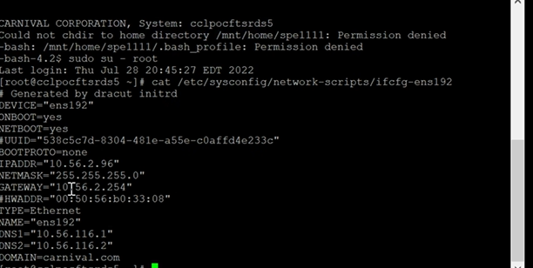
* 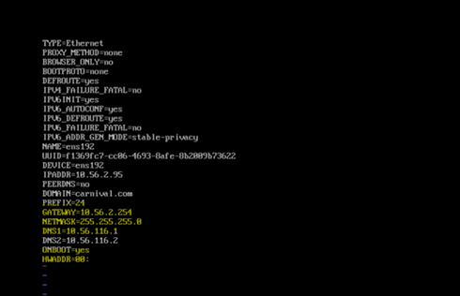
* Then need to change hostname -- vi /etc/hostname
* Then need to add host entry -- /etc/hosts
* 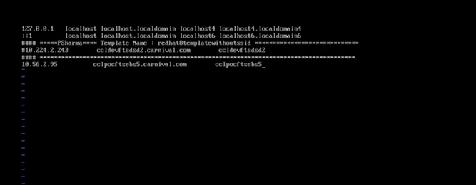

* Need to disable firewall

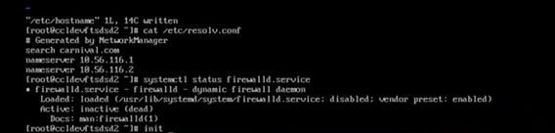

* 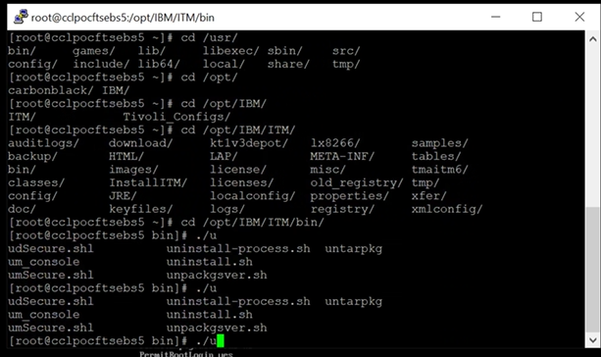
* 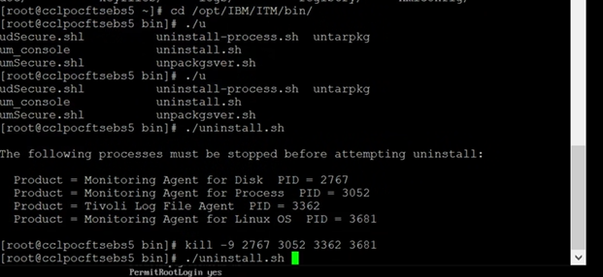
* 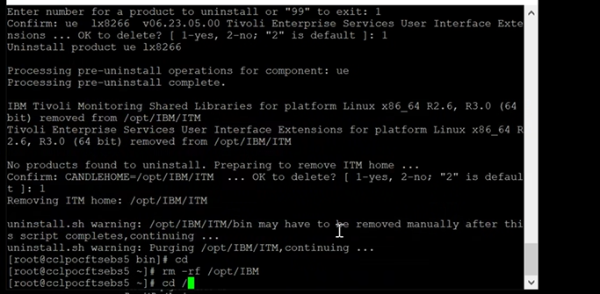
* Not connected through putty
* systremctl restart network-manager
* cd /etc/sysconfig/netwrok-scripts
* ifdown ifcfg-ens192

**CR200007208 - QR:38739 - diable Deprecated SSH Cryptographic Settings**

Check the below output

sshd -T | grep kex

sshd -T | egrep -iw "ciphers|kexalgorithms"

Take the backup of

cp /etc/ssh/ssh_config /etc/ssh/ssh_config_bkp010822

cp /etc/ssh/sshd_config /etc/ssh/sshd_config_bkp010822

Add the below lines

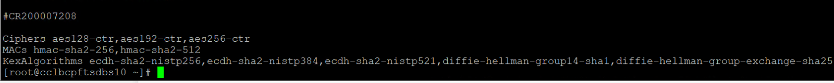

Ciphers aes128-ctr,aes192-ctr,aes256-ctr

MACs hmac-sha2-256,hmac-sha2-512

KexAlgorithms ecdh-sha2-nistp256,ecdh-sha2-nistp384,ecdh-sha2-nistp521,diffie-hellman-group14-sha1,diffie-hellman-group-exchange-sha256

Restart the sshd - systemctl reload sshd.service

Sample CR/INC

CR200006509 - Please decommission old Hyperion VMs

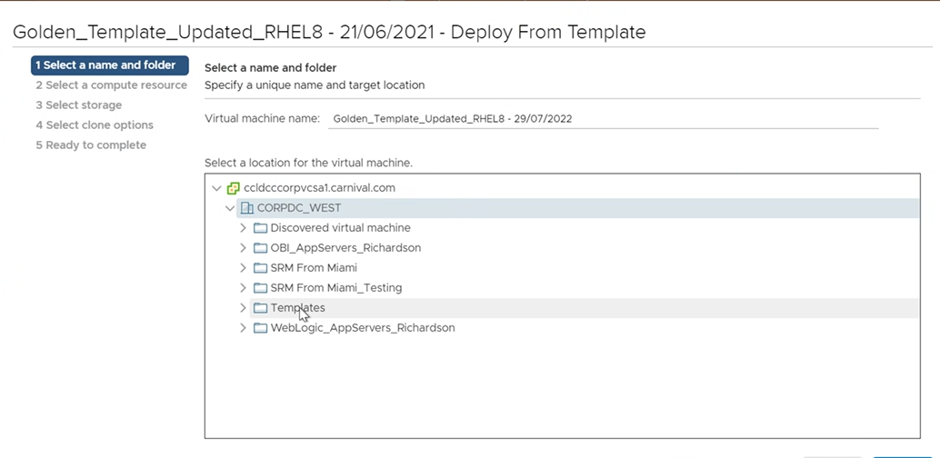

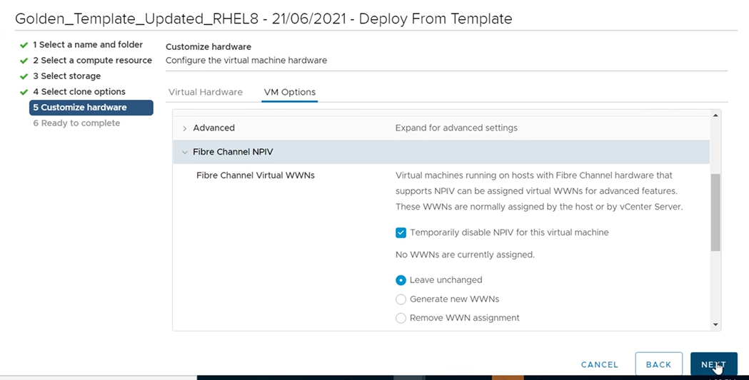

**CR200007382 - Disable SMBv1 on Linux Servers**

**RITM0690117** - **firewall request with network team to open the traffic**

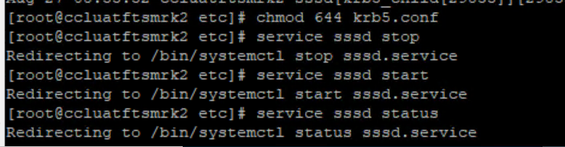

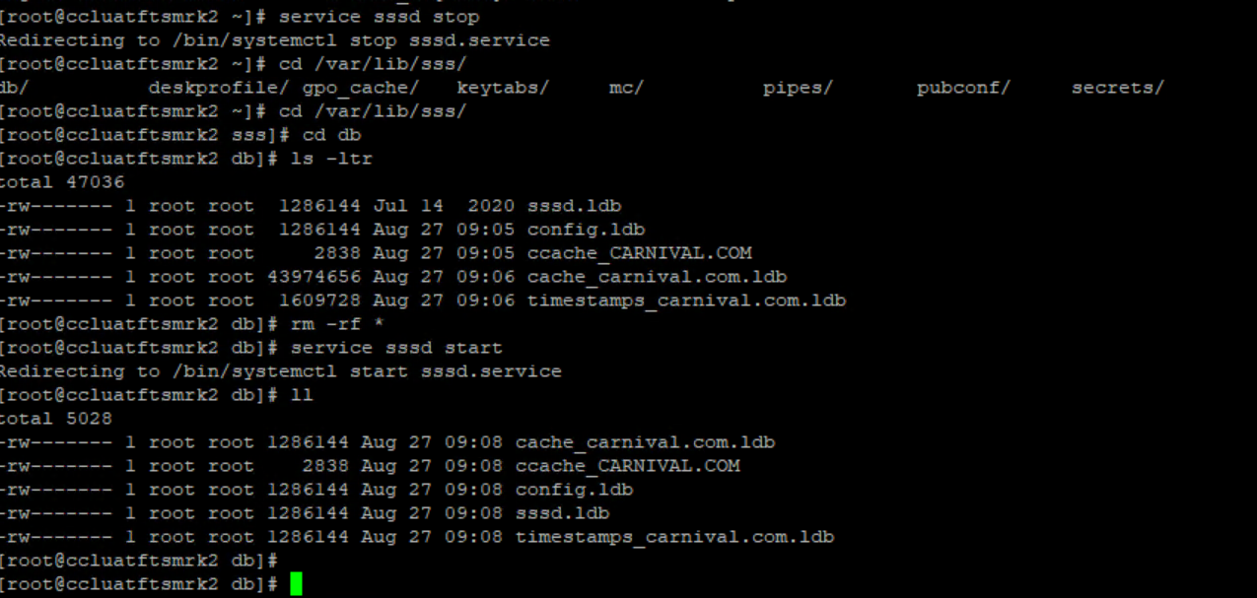

**Update java jre netbackup**:

* Download the java package - <https://www.java.com/en/download/linux_manual.jsp>
* Untar the jre tar -xvf jre-8u351-linux-x64.tar.gz

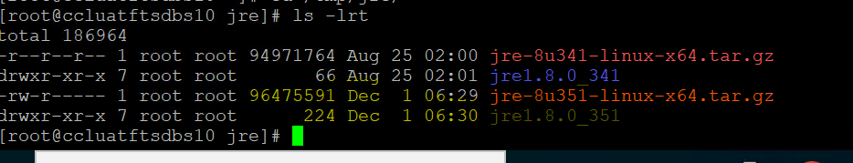

* /usr/openv/java/jre/bin/java -version
* /usr/openv/netbackup/bin/goodies/nbcomponentupate -product Netbackup -component jre -path /tmp/jre/jre1.8.0_351
* /usr/openv/java/jre/bin/java -version

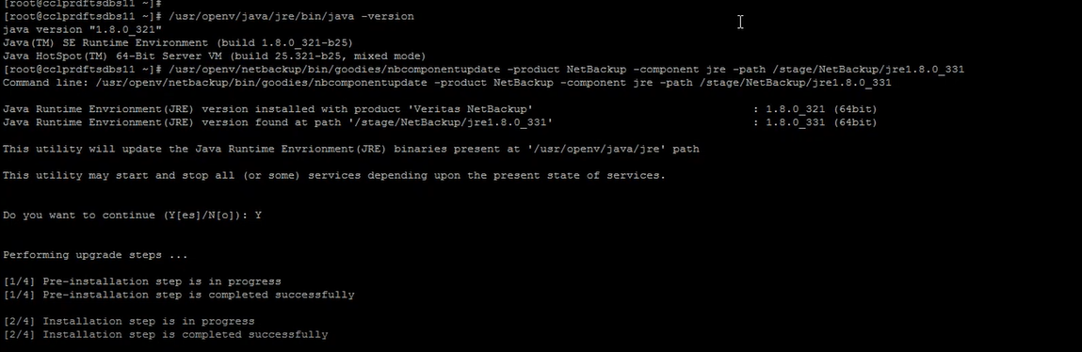

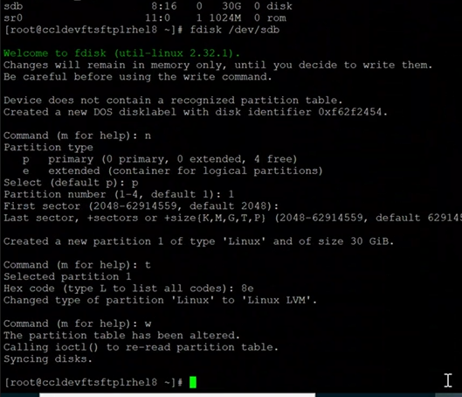

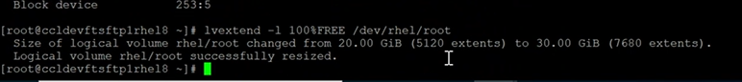

**Remove the server from tivoli:**

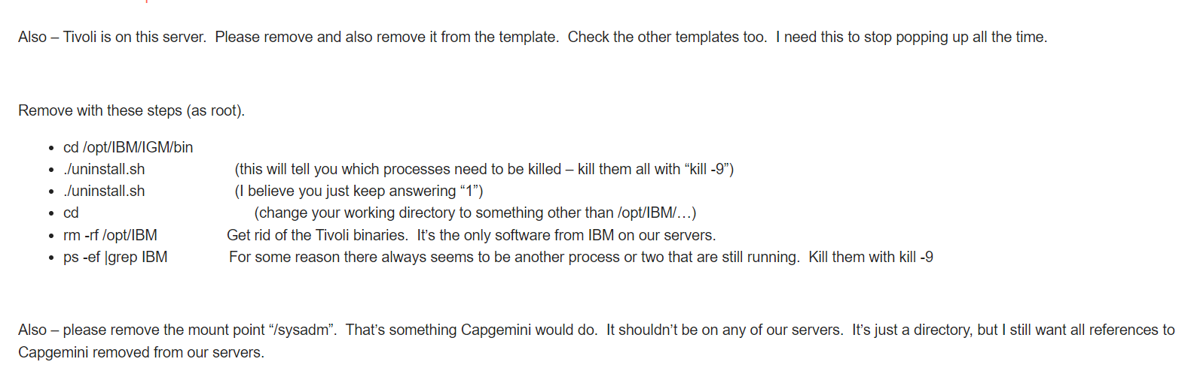

**To schedule the noop schedule**r -->

echo 'none' > /sys/block/sda/queue/scheduler

To check – cat /etc/block/sda/queue/scheduler |grep -I none

**File system is full /u03**

xfs_repair -L /dev.md12

Check the service -systemctl status systemd-sysctl.service

Need to edit the file - vi /etc/sysctl.conf

After 1 it’s showing single ‘. we need to remove it

Restart the services - systemctl restart systemd-sysctl.service and reboot it



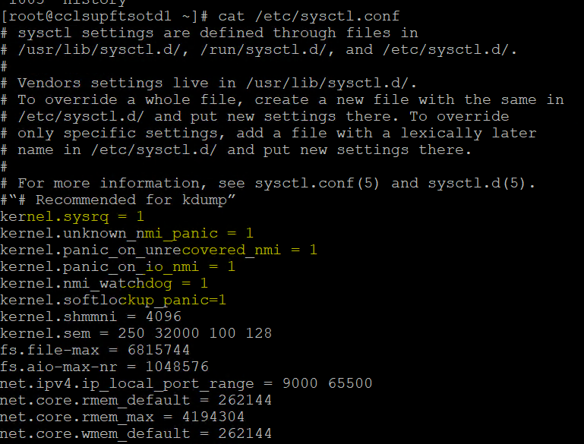

**Carbon black packages**

\\cclprdinfeng1.carnival.com\ntserver\ISS\CarbonBlack\Installers\CCL\edr.carnival.com\Linux\

—------------------------------------

**KRB file corrupted:**

Remove the /etc/krb5.keytab



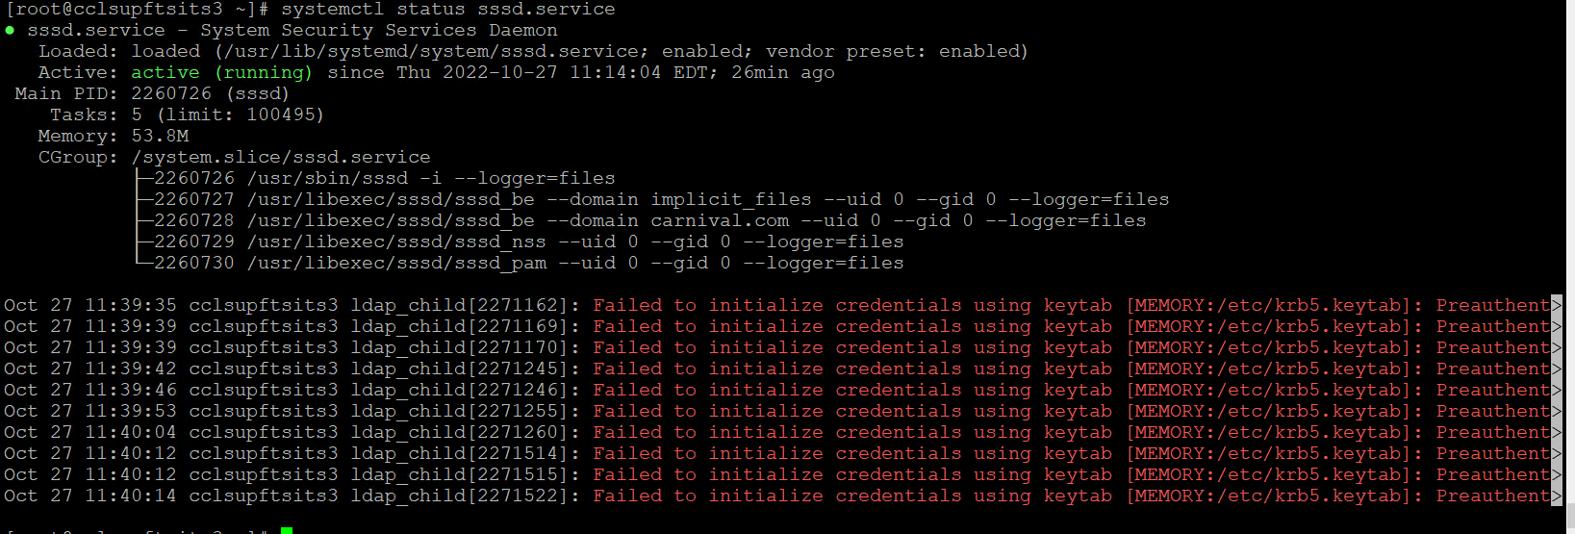

**Time sync issue:**

https://www.tecmint.com/set-time-timezone-and-synchronize-time-using-timedatectl-command/

*Check - timedatectl

*To list the timezone - timedatectl list-timezones – time zone not listed means reinstall the tzdata pkg

*To change the timezone – timedatectl set-timezone Asia/Kolkata

*Need to disable and stop the chrony - systemctl disable chronyd.service

*To set date and time manually - timedatectl set-time

*Start the chrony - systemctl enable chronyd.service

*To sync the time - timedatectl set-ntp true

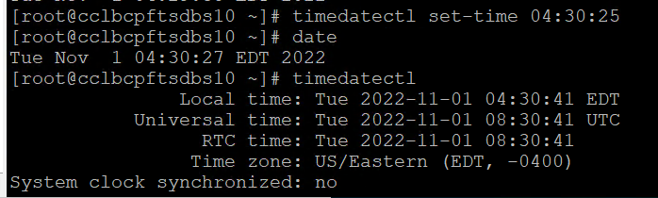

—---------------------------------

**RHEL 8 upgrade issue**:

While trying to upgrade we are facing unknown errors. Issue with NVME & RAID configurations

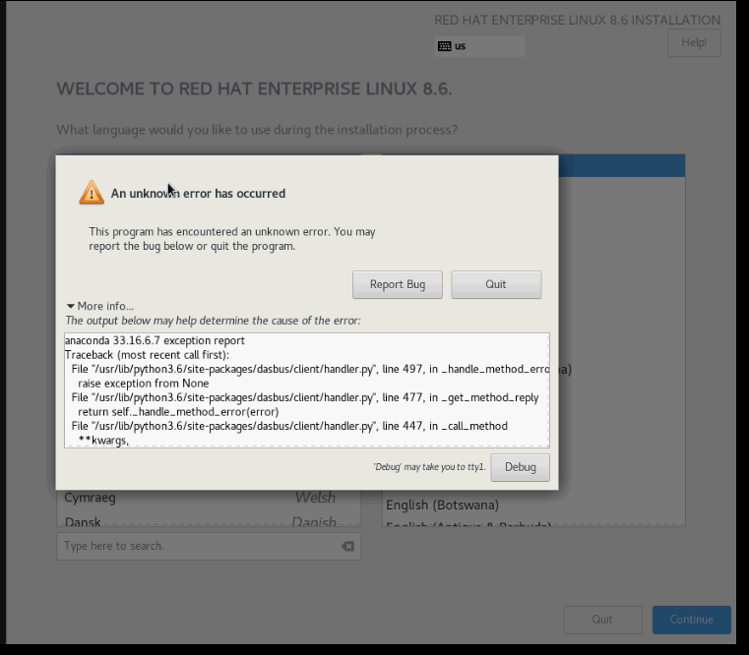

# dmesg &> /tmp/dmesg.log

# fdisk -l &> /tmp/fdisk.log

# parted -sl &> /tmp/parted.log

# cat /proc/partitions &> /tmp/proc_part.log

# multipath -ll &> /tmp/mpath.log

# ls -lR /dev &> /tmp/dev.log

# cat /proc/scsi/scsi &> /tmp/proc_scsi.log

# tar cvf installation_logs.tar /tmp/*log*

Reboot the server - select the kernel and edit – enter the below parameter

raid=noautodetect modprobe.blacklist=nvme modprobe.blacklist=nvme_core

Once the installation is complete we need to remove the above parameter.

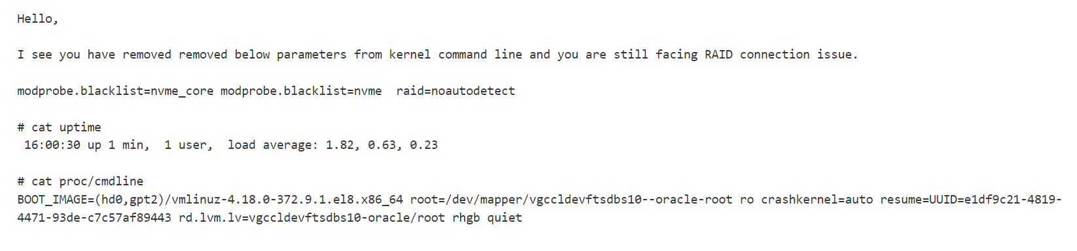

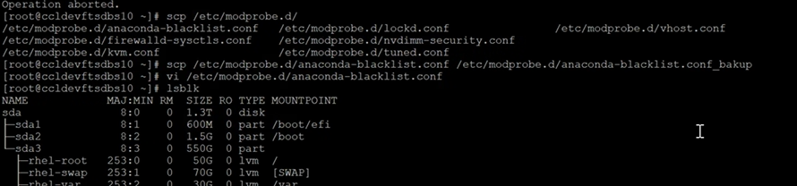

**Splunk installation:**

Download the package to the link - <https://www.splunk.com/en_us/download/previous-releases/universalforwarder.html>

Or

wget -O splunkforwarder-9.0.1-82c987350fde-linux-2.6-x86_64.rpm "[https://download.splunk.com/products/universalforwarder/releases/9.0.1/linux/splunkforwarder-9.0.1-82c987350fde-linux-2.6-x86_64.rpm"](https://download.splunk.com/products/universalforwarder/releases/9.0.1/linux/splunkforwarder-9.0.1-82c987350fde-linux-2.6-x86_64.rpm%22)

* Install → rpm -ivh splunkforwarder-9.0.1-82c987350fde-linux-2.6-x86_64.rpm

* export SPLUNK_HOME="/opt/splunkforwarder"

* mkdir $SPLUNK_HOME

* $SPLUNK_HOME/bin/splunk start --accept-license --answer-yes

* ps -ef | grep splunk

* $SPLUNK_HOME/bin/splunk stop

* $SPLUNK_HOME/bin/splunk enable boot-start -systemd-managed 1 -user splunk

* chown -R splunk:splunk /opt/splunkforwarder

* systemctl start SplunkForwarder.service

* ps -ef | grep splunk

* mkdir -p $SPLUNK_HOME/etc/apps/giscs_all_deploymentclient/local

* vi $SPLUNK_HOME/etc/apps/giscs_all_deploymentclient/local/deploymentclient.conf

**Add the following contents to the deploymentclient.conf file:**

i. For CCL Brand Shoreside and Shipboard Installations:

[deployment-client]

# Set the phoneHome at the end of the PS engagement

# 10 minutes

phoneHomeIntervalInSecs = 600

[target-broker:deploymentServer]

# Change the targetUri

targetUri = 10.224.97.109:8089

ii. For PCL Brand Shoreside and Shipboard Installations:

[deployment-client]

# Set the phoneHome at the end of the PS engagement

# 10 minutes

phoneHomeIntervalInSecs = 600

[target-broker:deploymentServer]

# Change the targetUri

targetUri = 10.57.163.13:8089

* $SPLUNK_HOME/bin/splunk restart

* setfacl -R -m u:splunk:rX /var/log && setfacl -R -d -m u:splunk:rX /var/log

—-----------------------

**To increase the SWAP memory:**

**AD issue :**

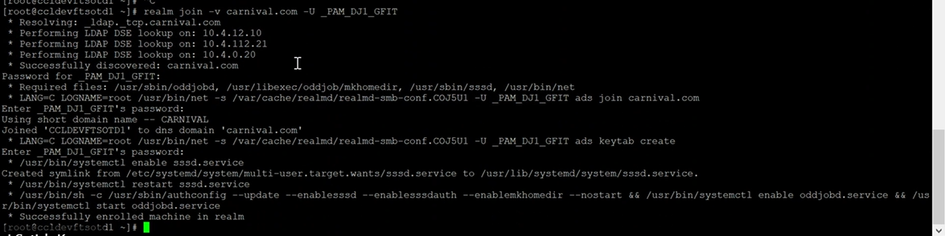

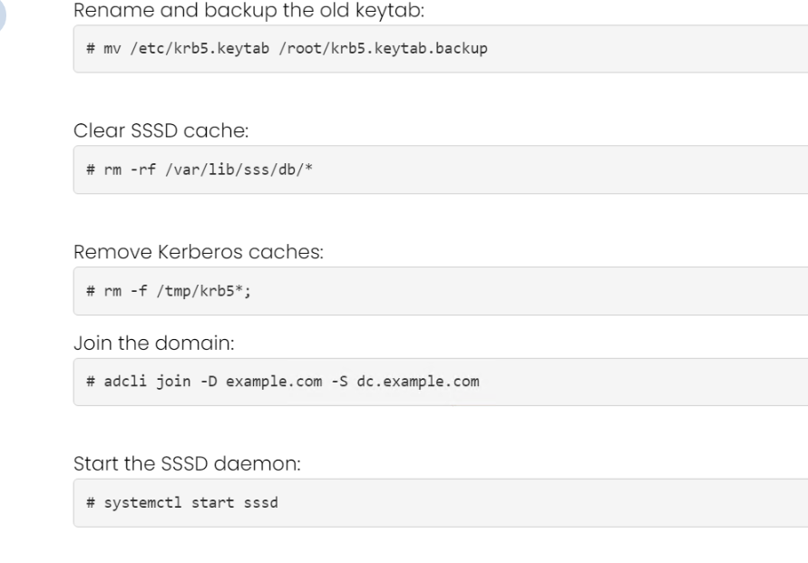

**Ansible:**

* Build the ansible server and install the ansible package
* Service account created - ansible
* Generate the key for the ansible -- sshkeygen
* local account created - _gfit_ansible
* Add the user in /etc/sssd/sssd.conf - simple allow user (_gfit_ansible)
* create home directory for the _gfit_ansible -- install the sssd-tools
* #sss_override user-add _gfit_ansible -h /home/_gfit_ansible
* Once created need to uninstall the sssd-tools
* Added the local user in /etc/sudoers.d/AD-groups
* copy the key in test servers
* check the connection between ansible and test servers

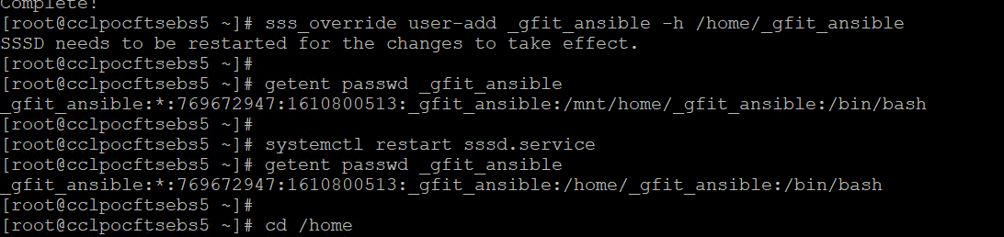

Duplicate IPv6 addresses – Need to change the machine-id, since machine id should be unique.



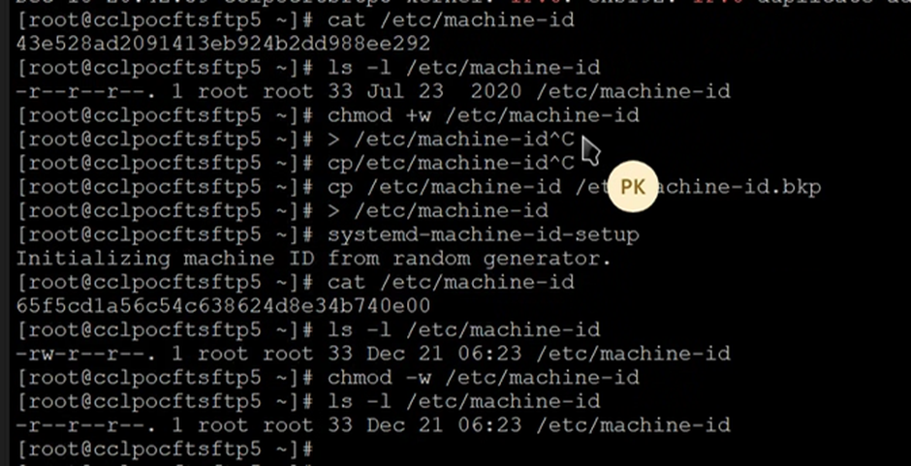

**To change machine ID:**

cat /var/log/messages |grep -i ipv6

cat /etc/machine-id

ls -l /etc/machine-id - check the permissions

chmod +w /etc/machine-id - assigin write permissions

cp /etc/machine-id /etc/machine-id.bkp - take a backup

> /etc/machine-id

systemd-machine-id-setup ----generate new machine id.

cat /etc/machine-id --check machine id is changed or not

chmod -w /etc/machine-id --- remove the write permission

ls -l /etc/machine-id ------check the permissions as default or not.

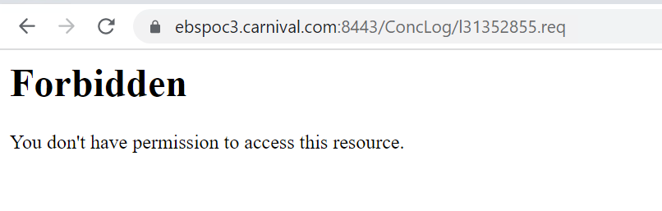

chcon --user system_u --type httpd_sys_content_t -Rv /var/www/html/ConcLog/

chcon --user system_u --type httpd_sys_content_t -Rv /var/www/html/ConcOut/

Restart the httpd.service

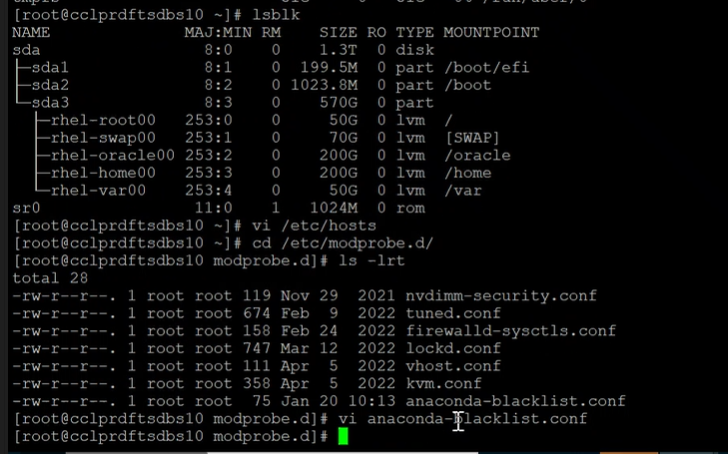

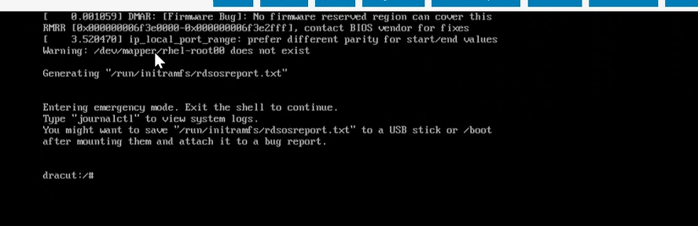

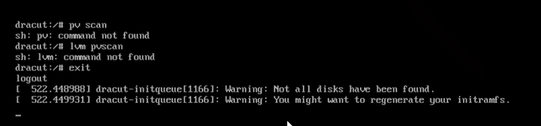

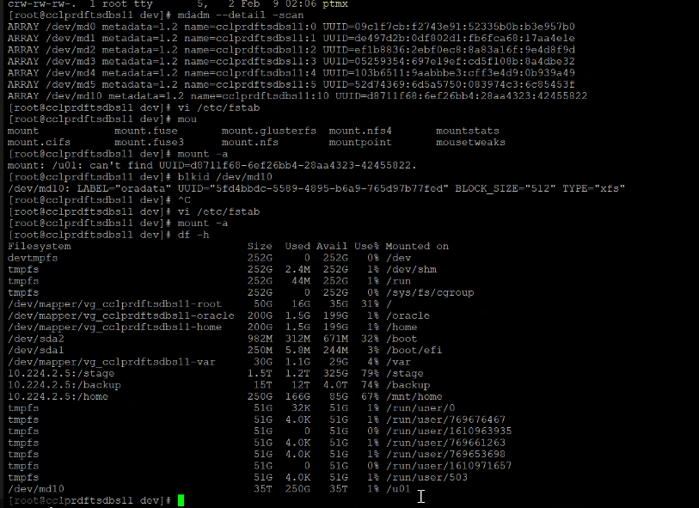

**Facing below error to remove rpm pkg:**

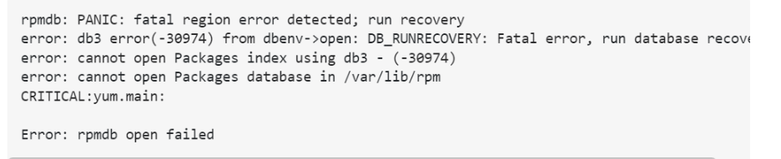

* rpm -qa |grep -i pkgname
* mkdir /root/backups.rpm.270223
* cp -avr /var/lib/rpm/ /root/backups.rpm.270223/
* rm -f /var/lib/rpm/__db*
* db_verify /var/lib/rpm/Packages
* rpm --rebuilddb
* yum clean all

**Satellite server web:**

Backend service error —> satellite-maintain service restart

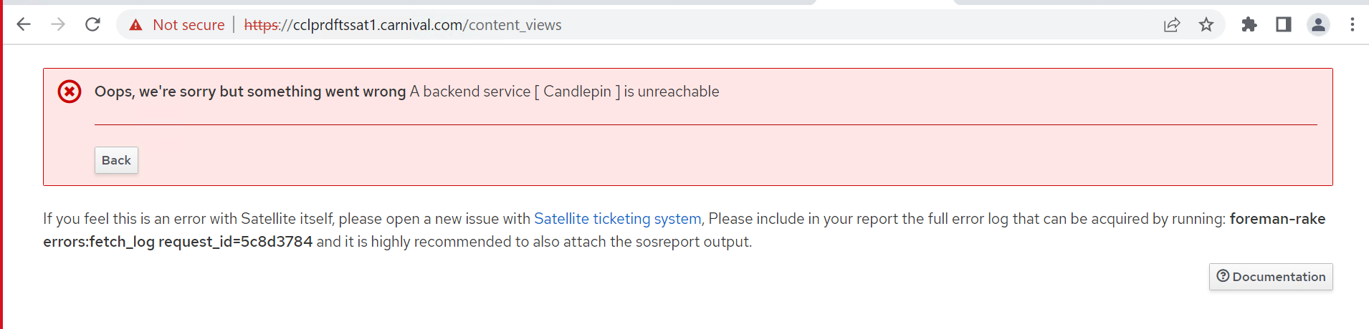

**Root password not able to change:**

Cd /etc/pam.d → password-auth and system-auth – Need to uncomment the password sufficient line

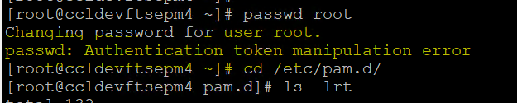

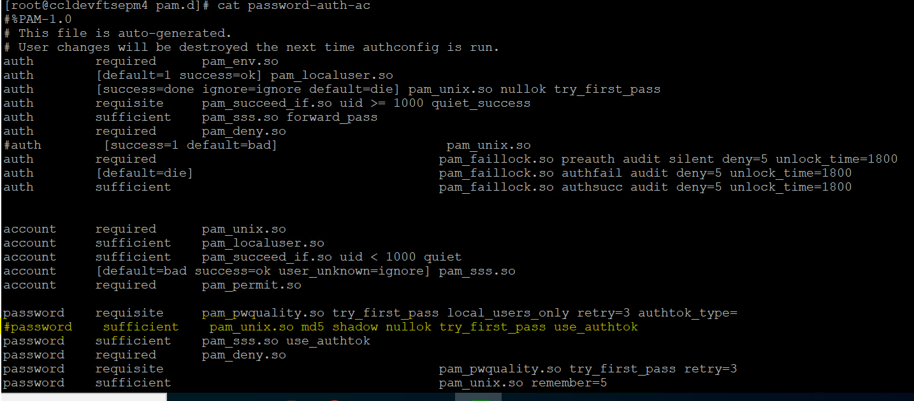

**Offline CPU remove from Putty**

List all present vCPUs/CPUs of the system

#ls -l /sys/devices/system/cpu | grep cpu

List all working vCPUs/CPUs of the system

#cat /proc/cpuinfo |grep processor

Hot-remove vCPUs from the system

#echo 0 > /sys/devices/system/cpu/cpuX/online

We can check the online/offline vCPUs

# cat /sys/devices/system/cpu/online   
 # cat /sys/devices/system/cpu/offline

**Scripts:**

echo "  
 #  
 # CR200009318 - To get server hardening information  
 #  
 nagios ALL = NOPASSWD:/usr/sbin/modprobe -n -v *  
 nagios ALL = NOPASSWD:/usr/sbin/subscription-manager identity  
 nagios ALL = NOPASSWD:/usr/bin/dnf repolist" >> /etc/sudoers.d/AD-Groups

========================================================

#!/bin/bash

for server in `cat /home/ansible/sudoers/servers.txt`  
 do  
 echo "Connecting to $server"  
 ssh _gfit_ansible@$server "sudo sed -i 's/, _svcaddmu@carnival.com//g' /etc/sssd/sssd.conf"  
 ssh _gfit_ansible@$server "sudo sed -i '/_svcaddmu/d' /etc/sudoers"  
 ssh _gfit_ansible@$server "sudo userdel _svcaddmu"  
 ssh _gfit_ansible@$server "sudo systemctl restart sssd.service"  
 echo "Completed $server"

done  
 ==========================================================  
 #!/bin/bash

for server in `cat /home/ansible/sudoers/servers.txt`  
 do  
 echo "Connecting to $server"  
 ssh _gfit_ansible@$server "sudo sed -i 's/ccldccprddc2.carnival.com/ccldccftsdc1/g' /tmp/sssd.conf"  
 ssh _gfit_ansible@$server "sudo sed -i '/^ad_server/a ad_backup_server = ccldccftsdc2' /tmp/sssd.conf"  
 ssh _gfit_ansible@$server "sudo sed -i 's/10.56.116.1/10.56.2.1/g' /tmp/ifcfg-ens192"  
 ssh _gfit_ansible@$server "sudo sed -i 's/10.56.116.2/10.56.2.2/g' /tmp/ifcfg-ens192"  
 #ssh _gfit_ansible@$server "sudo systemctl restart Networkmanager.service"  
 #ssh _gfit_ansible@$server "sudo systemctl restart sssd.service"

echo "Completed $server"  
 done

================================================

#!/bin/bash

for server in `cat /home/ansible/scripts/servers.txt`  
 do  
 echo "Connecting to $server"  
 ssh _gfit_ansible@$server "sudo subscription-manager refresh "  
 ssh _gfit_ansible@$server "sudo yum update -y"  
 done

===================================================

Imperva agent -/opt/imperva/ragent/bin/rainit start

- What filesystem did you repair ?   
 /var/log  
 /var/log/audit  
 /var/tmp

- What command was executed to repair the filesystem ?  
 xfs_repair /dev/mapper/rhel-var_tmp  
 xfs_repair /dev/mapper/rhel-var_log  
 xfs_repair /dev/mapper/rhel-var_log_audit

========================================

$ echo 'none' > /sys/block/sda/queue/scheduler -noop scheduler

===========================================

rpm --import ./microsoft.asc

**Sodexo**

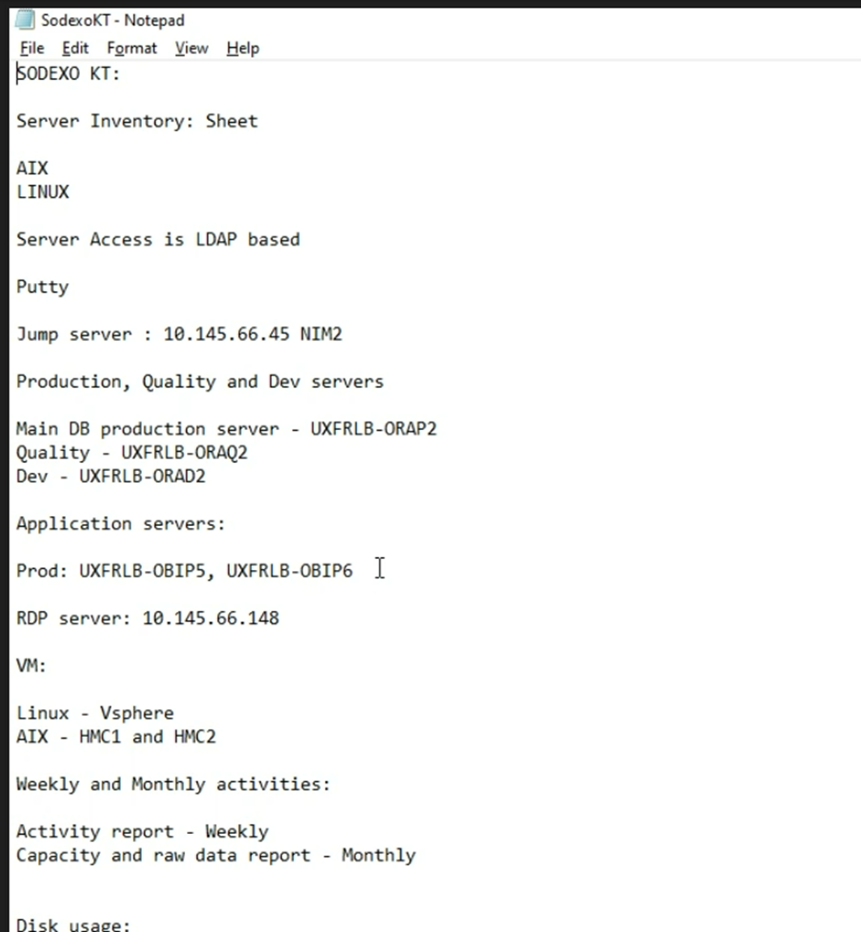

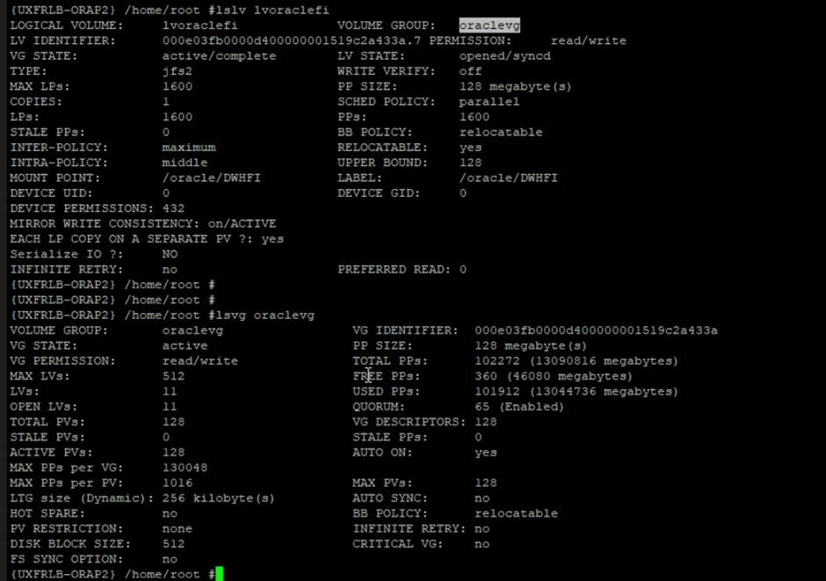

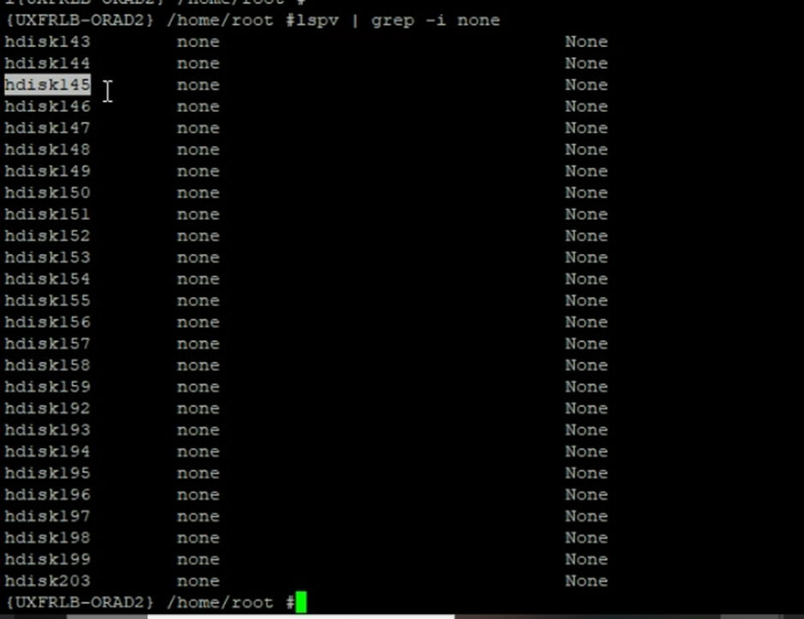

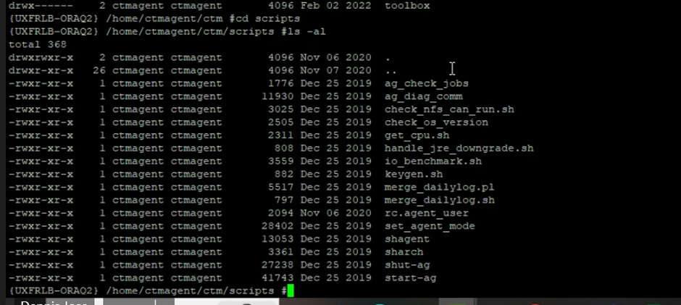

**Vistara:**

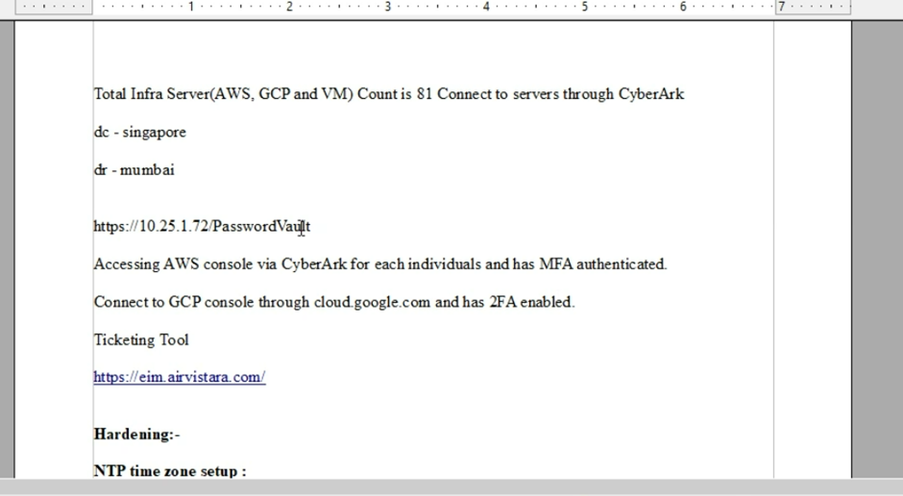

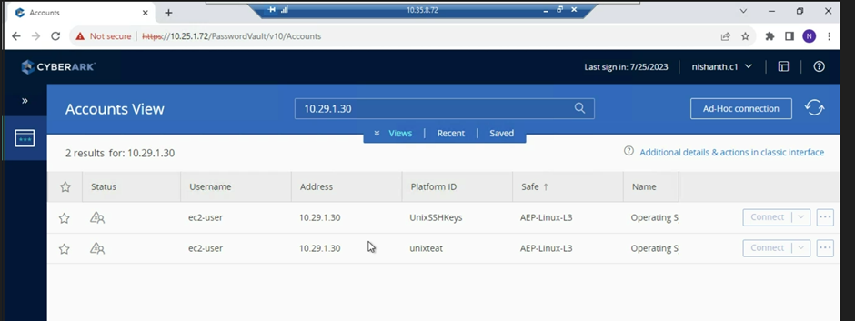

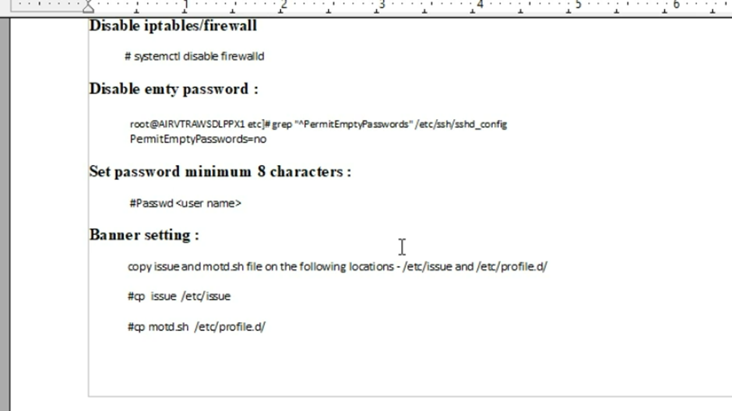

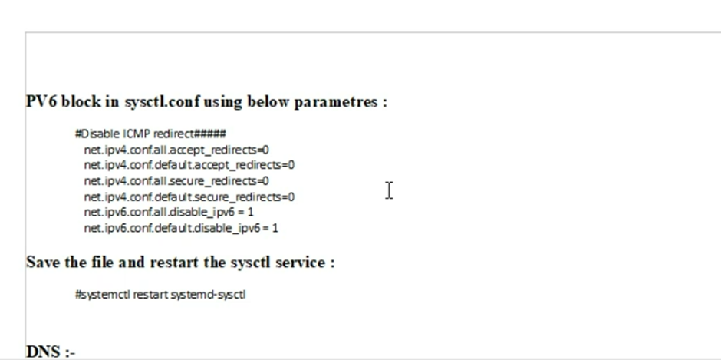

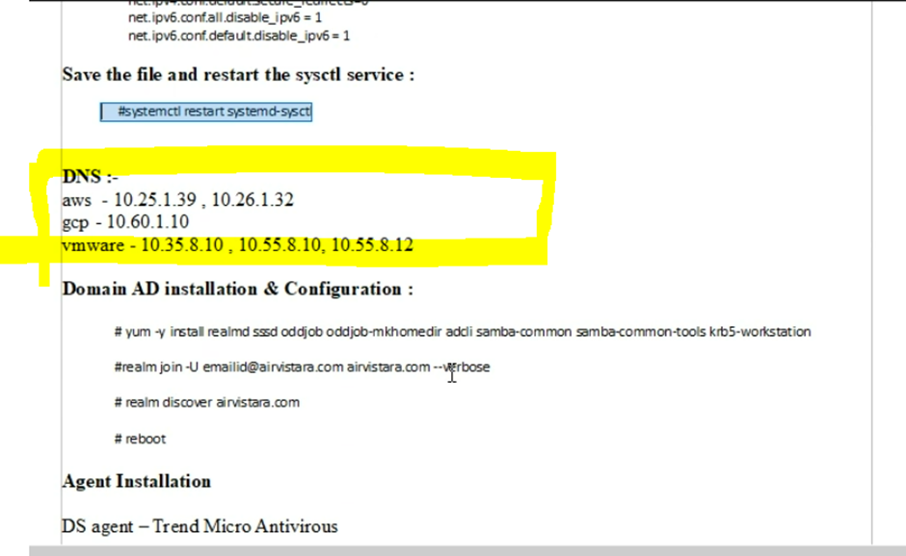

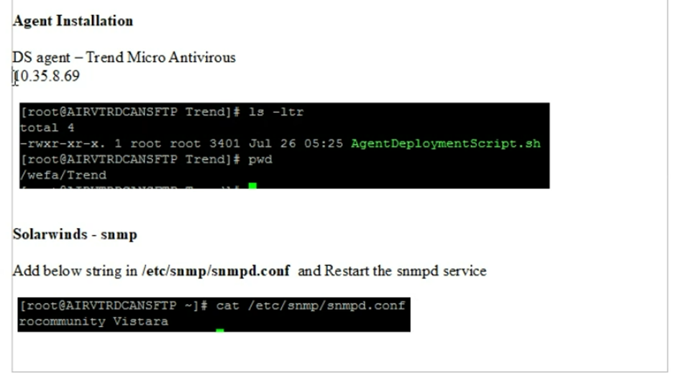

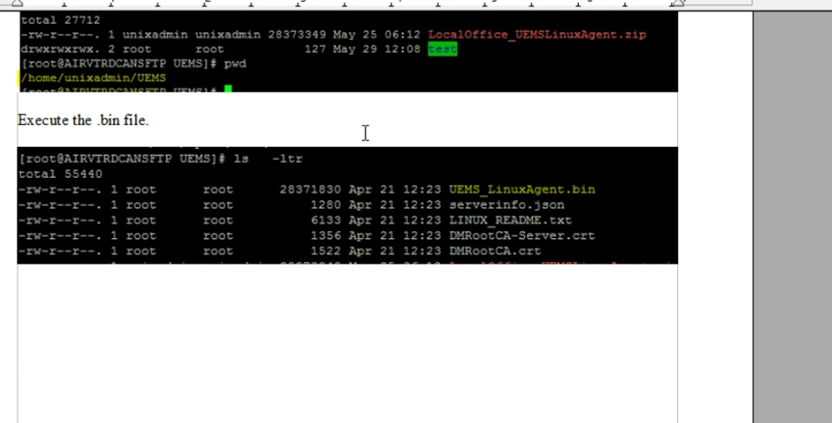

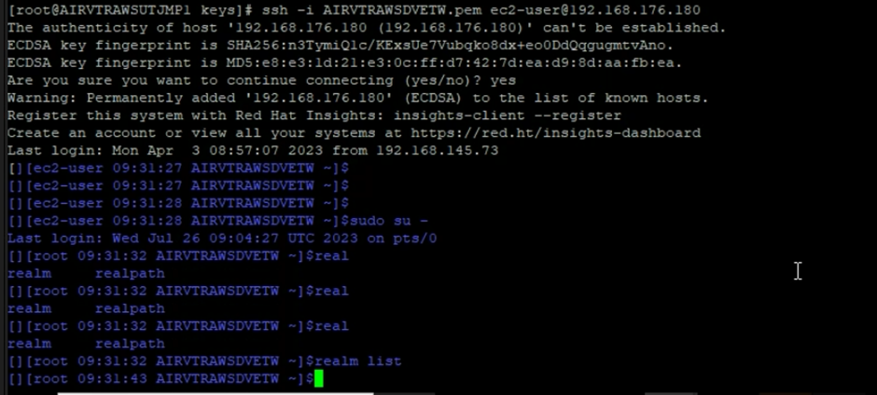

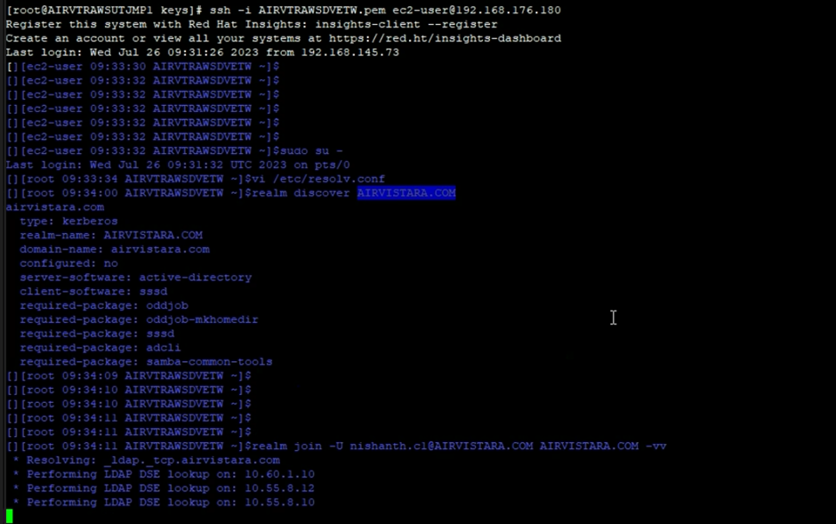

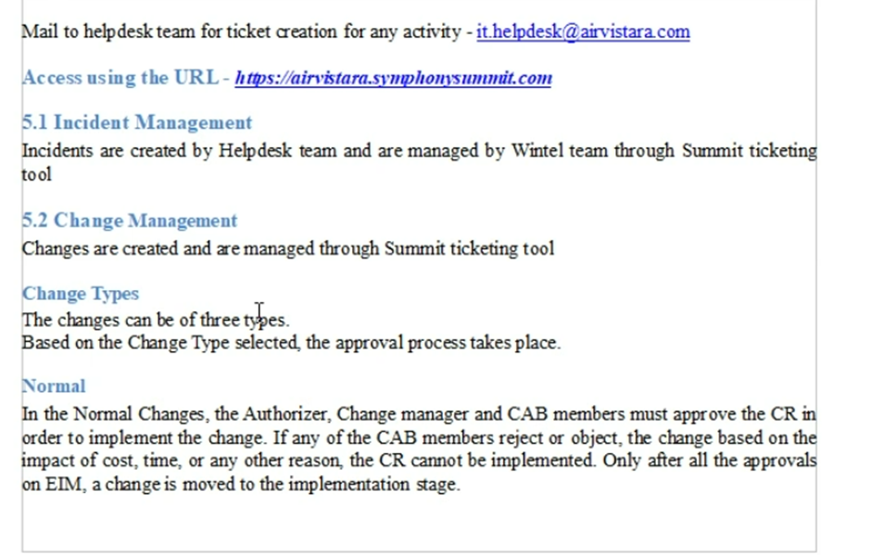

**Ecom server access:**

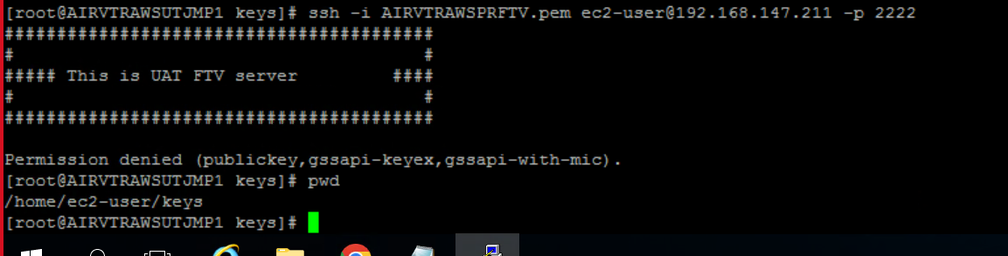

**MAG**

main file transfer server.

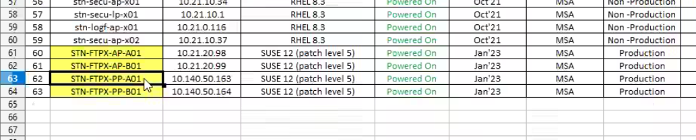

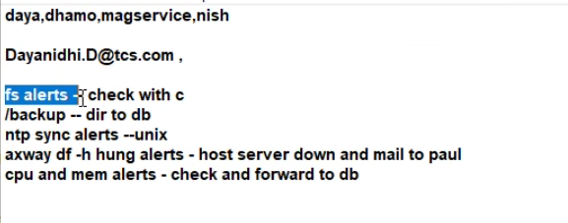

Dayanidhi.D@tcs.com , DHAMOTHARAN.MANICKAM@magairports.com , magservice.desk@magairports.com ,mag.servicedesk@tcs.com ,MAG.Application@tcs.com   
 stnittechteam@stanstedairport.com, c.nishanth@tcs.com

fs alerts -- check with client t  
 /backup -- forward to db   
 ntp sync alerts --unix   
 axway df -h hung alerts - host server down and mail to paul -- paul.bunn@magairports.com   
 cpu and mem alerts - check and forward to db

yum reinstall --downloadonly --downloaddir=/tmp openssh openssh-clien



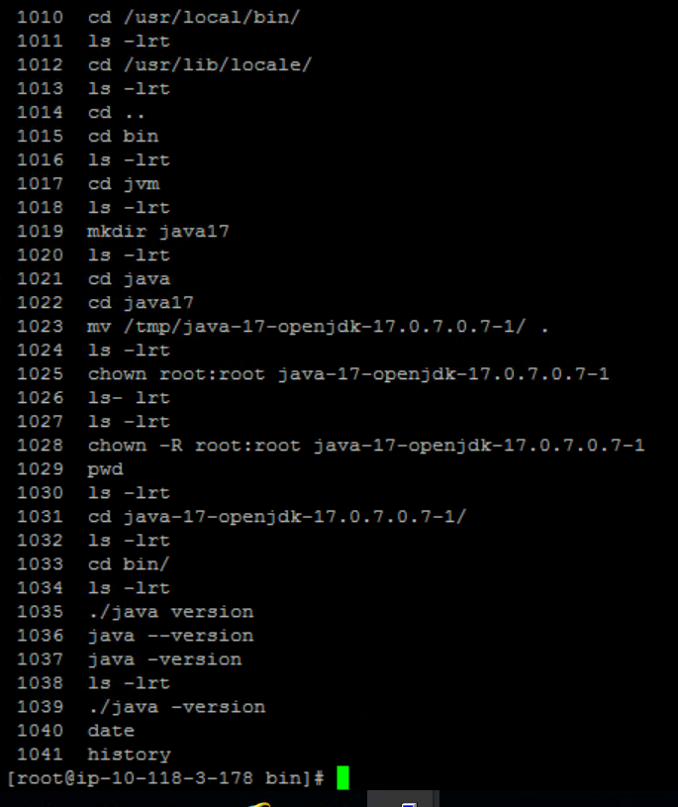

10.118.3.170 – Ldap jump server – star

service sladp restart

